**PENGARUH RASIO SODIUM ALGINAT-GUM ARABIC DAN KONSENTRASI MINYAK KAYU MANIS (*Cinnamomum burmannii*) TERHADAP SIFAT FISIK, MEKANIK, DAN ANTIMIKROBA PADA EDIBLE FILM**

*The Effect Of Sodium Alginate/Gum Arabic Ratio And Cinnamon Oil (Cinnamomum burmannii) Concentration On Physical, Mechanical, And Antimicrobial Properties In Edible Film*

**OLEH**

**CLARA NOVELIA JESSICA SULI**

**G031181301**



**PROGRAM STUDI ILMU DAN TEKNOLOGI PANGAN**

**DEPARTEMEN TEKNOLOGI PERTANIAN**

**FAKULTAS PERTANIAN**

**UNIVERSITAS HASANUDDIN**

**MAKASSAR**

**2022**

**PENGARUH RASIO SODIUM ALGINAT-GUM ARABIC DAN KONSENTRASI MINYAK KAYU MANIS (*Cinnamomum burmannii*) TERHADAP SIFAT FISIK, MEKANIK, DAN ANTIMIKROBA PADA EDIBLE FILM1)**

*The Effect Of Sodium Alginate-Gum Arabic Ratio And Cinnamon Oil (Cinnamomum burmannii) Concentration On Physical, Mechanical, And Antimicrobial Properties In Edible Film*

**Clara Novelia Jessica Suli2) Adiansyah Syarifuddin3) Andi Hasizah3)**

**ABSTRAK**

**Latar belakang** Edible film merupakan kemasan primer ramah lingkungan yang dapat mempertahankan mutu dari produk pangan. Edible film terbuat dari tiga jenis bahan penyusun antara lain hidrokoloid, lipid, dan pati. Penambahan minyak kayu manis pada edible film dapat berfungsi sebagai antibakteri. **Tujuan** penelitian ini, yaitu untuk mengetahui konsentrasi sodium alginat/gum arabic yang tepat pada edible film sehingga menghasilkan edible film yang berkualitas dan berkarakteristik baik dan untuk mengetahui konsentrasi terbaik dari minyak kayu manis sebagai antimikroba pada edible film. **Metode** dari penelitian ini, adalah pembuatan larutan alginat dan gum arabic, pembuatan edible film dan penambahan minyak kayu manis yang kemudian dianalisis pada edible film dan penggunaan/pengaplikasian edible film pada daging. **Hasil** pengujian tahap 1 menunjukan bahwa perlakuan terbaik yang diperoleh berdasarkan sifat fisik mekanik edible film yaitu terdapat pada perlakuan rasio 1,5% sodium alginat : 1,5% gum arabic dengan penambahan minyak kayu manis 36,1 mg/mL (ketebalan 0,014 mm; LTUA 11,15 g/jam.m 2 ; daya larut 65,50; kuat tarik 0,01 N/mm 2 ). Hasil pengujian tahap 2 pada edible film dengan penambahan minyak kayu manis sebanyak 36,2 mg/mL yang diaplikasikan pada daging sapi memiliki daya hambat terhadap bakteri gram negatif (E. coli) sebesar 15,40 mm dan bakteri gram positif (S.aureus) sebesar 16,51 mm, mampu mempertahankan warna dan pH daging selama penyimpanan, serta mampu menghambat pertumbuhan mikroba pada fillet daging sapi, dan penilaian organoleptik yang masih baik pada fillet daging sapi selama penyimpanan. **Kesimpulan** penelitian ini yaitu rasio pada sodium alginat dengan gum arabic dan penambahan minyak kayu manis berpotensi dalam memperbaiki sifat fisik mekanik dari edible film. Penambahan minyak kayu manis pada edible film mampu menghambat bakteri gram positif dan negatif dari zona hambat yang tergolong sangat kuat serta dalam pengaplikasian pada daging sapi mampu mempertahankan warna dan pH serta menghambat pertumbuhan mikroba selama 8 hari penyimpanan.

*Kata kunci : Edible film, gum arabic, minyak kayu manis, sodium alginat.*

**BAB I. PENDAHULUAN**

**I.1 Latar Belakang**

*Edible film* merupakan pengemas bahan pangan yang terbuat dari bahan yang ramah lingkungan karena bersifat terbarukan. Pengemas memiliki fungsi untuk melindungi bahan pangan dari kerusakan dan menurunkan mutu dari bahan pangan itu sendiri. Umumnya pengemas menggunakan bahan plastik karena harganya yang murah dan mudah untuk ditemui. Penggunaan plastik yang meningkat pada akhirnya dapat memberikan dampak negatif pada lingkungan, hal ini dikarenakan plastik sulit untuk di daur ulang (Bao dan Hanh, 2008). Seiring dengan berkembangnya teknologi pada makanan, maka dikembangkanlah jenis kemasan bersifat *biodegradable* dari bahan organik yang dapat dimakan dan kecil kemungkinan terkena kontaminasi dalam bentuk *edible film*. Selain ramah lingkungan, *Edible film* dapat mengontrol kelembaban, oksigen, karbon dioksida, lipid, aroma dan rasa aditif untuk meningkatkan kualitas masa simpan bahan makanan hingga beberapa hari dan dapat memberikan kualitas produk pangan yang lebih baik.

*Edible film* merupakan salah satu alternatif untuk memperpanjang umur simpan yang bertindak sebagai penghalang uap air, oksigen, dan karbon dioksida dan sebagai pembawa zat untuk menghambat mikroba patogen dan pembusuk (Ortega et al., 2014). *Edible film* diperoleh dari suspensi *filmogenic food grade* yang umumnya dicetak di atas permukaan inert, yang dapat ditempatkan dalam kontak dengan permukaan makanan. *Edible film* terdiri dari polisakarida, protein, dan lipid yang terbuat dari berbagai produk pertanian dan limbah pengolahan makanan dan produk sampingan (Huang et al. 2019). Bahan yang umumnya digunakan dalam pembuatan *edible film* yakni jenis umbi-umbian yang mengandung pati. Pemanfaatan pati sebagai bahan baku edible film memiliki kemampuan untuk melindungi produk terhadap oksigen, karbondioksida, minyak, dan meningkatkan kesatuan struktur produk. Saat ini, bahan biopolimer seperti karbohidrat, kitosan, protein, lipid, dan campuran paling sering digunakan untuk memproduksi *edible film* (Ali and Ahmed 2018).

Bahan biopolimer seperti polimer karbohidrat memiliki kompatibilitas yang lebih baik daripada protein dan film lipid. Hal ini dikarenakan asam amino dan asam lemak merupakan bahan mahal yang menunjukkan stabilitas termal dan kelarutan air yang buruk, selain itu beberapa bahan ini alergi terhadap manusia (Shit dan Shah 2014). Natrium alginat yang merupakan makromolekul karbohidrat berbasis alga yang menguntungkan yang memiliki sifat pembentuk film potensial pada hidrolisis dan banyak terdapat di dinding sel sebagai campuran berbagai garam. Film sodium alginat adalah faktor anti-mikroba untuk peningkatan kualitas umur simpan. Alginat merupakan produk yang dihasilkan dari proses ekstraksi rumput laut coklat.

Gum arab adalah lapisan polisakarida yang banyak digunakan karena sifat pembentuk film yang baik, emulsifikasi yang unik, sifat enkapsulasi karena sifat amfifiliknya yang terkenal. Namun, ada beberapa aplikasi yang menggunakan gum arab untuk aplikasi pelapisan atau film dan di sisi lain, natrium alginat, polisakarida yang diekstraksi terutama dari alga laut, menunjukkan sifat yang menarik untuk aplikasi film karena biaya rendah, biokompatibel, *biodegradable* dan karakteristik pembentuk film yang baik. Gum arabic sebagai *edible film* dapat berfungsi sebagai bahan pengisi sehingga menghasilkan *edible film* yang memiliki kuat tarik yang baik (Santoso et al., 2014). Kedua fase polimer membentuk sistem multikomponen amorf yang stabil secara termal dan dapat bercampur sepenuhnya yang dapat digunakan sebagai bahan polimer yang stabil secara termal dalam perangkat elektronik.

Kemasan *edible film* memiliki kemampuan untuk dalam melindungi suatu produk pangan dan kemampuan sebagai antimikroba dapat menghentikan, menghambat, mengurangi atau memperlambat pertumbuhan mikroorganisme patogen pada makanan dan bahan kemasan. Oleh karena itu, perlunya senyawa yang bersifat hidrofobik sehingga karakteristik *edible film* yang dihasilkan lebih baik. Antimikroba alami dapat dimasukkan ke dalam suspensi *edible film*, menambahkan fungsionalitas pada film dan pelapis yang dapat dimakan, yang mengarah pada perolehan film dan pelapis yang dapat dimakan antimikroba. Minyak kayu manis merupakan salah satu senyawa yang dapat digunakan untuk menyeimbangkan polimer hidrofilik dan hidrofobik pada film sehingga mampu memperbaiki laju transmisi uap air yang kurang baik pada *edible film*. Penambahan minyak kayu manis pada *edible film* dapat merusak dinding sel pada mikroba lalu menyebabkan lisis, kemudian membunuh mikroba yang terdapat pada bahan pangan. Sehingga kemasan *edible film* dapat meningkatkan masa simpan serta kualitas dari produk.

Kemasan antimikroba dapat melindungi daging dari kontaminasi patogen dengan mencegah pertumbuhan mikroba. Proses pengolahan daging dari pemotongan serta pengolahan dapat menyebabkan pertumbuhan mikroba. Menurut (M. Ahmad et al. 2012), aplikasi film pada permukaan daging dalam beberapa kasus dapat meningkatkan stabilitas warna daging merah, tetapi jika pelapis bertindak sebagai penghalang gas, perubahan warna yang tidak diinginkan dapat terjadi. Mikroba yang telah berkembang pada daging dapat menyebabkan perubahan kualitas pada daging antara lain yaitu aroma dan perubahan warna. Senyawa antioksidan yang digunakan ke dalam matriks polimer dapat mencegah pertumbuhan mikroorganisme pembusuk dan patogen, menunda ketengikan lemak daging, mencegah perubahan warna, dan bahkan meningkatkan kualitas gizi makanan berlapis (Soliva-Fortuny et al., 2012). Minyak atsiri umumnya menunjukkan aktivitas antibakteri yang lebih tinggi daripada campuran komponen antimikroba utama. Oleh sebab itu dilakukan penelitian ini untuk mengetahui pengaruh penambahan minyak kayu manis pada sifat fisik, mekanik, dan antimikroba pada *edible film* sodium kombinasi alginate/gum arabic pada daging sapi.

**I.2 Rumusan Masalah**

Edible film merupakan alternatif pengemasan yang bersifat biodegradable yang dapat melindungi produk pangan dari kerusakan fisika, kimia, dan biologi. Bahan baku edible film didapatkan menggunakan kombinasi alginate dan gum arabic sehingga dapat meningkatkan mutu dan umur simpan dari daging. Penambahan minyak kayu manis pada edible film dengan itu perlunya mengetahui sifat fisik, mekanik, dan antimikroba yang terkandung sehingga menghasilkan edible film yang baik dan sesuai.

**I.3 Tujuan Penelitian**

Tujuan dari kegiatan penelitian ini adalah sebagai berikut:

1. Untuk mengetahui ratio sodium alginat:gum arabic yang tepat pada edible film sehingga menghasilkan edible film yang berkualitas dan berkarakteristik baik.
2. Untuk mengetahui konsentrasi minyak kayu manis yang terbaik terhadap sifat fisik, mekanik, dan antimikroba pada edible film*.*

**I.4 Manfaat Penelitian**

Manfaat penelitian ini bagi peneliti, dapat meningkatkan ilmu pengetahuan dan teknologi serta wawasan akan sifat fisik, mekanik, dan antimikroba pada edible film dengan penambahan minyak kayu manis untuk mempertahankan mutu daging serta menghasilkan kemasan edible film dengan kualitas baik dan dapat diaplikasikan pada produk pangan.

**BAB II. METODE PENELITIAN**

**III.1 Waktu dan Tempat Penelitian**

Penelitian ini dilaksanakan pada bulan Oktober 2021 - Juli 2022 di Laboratorium Pengembangan Produk dan Kimia Analisa, Laboratorium Bioteknologi dan Mikrobiologi Pangan, Program Studi Ilmu dan Teknologi Pangan, Departemen Teknologi Pertanian, Fakultas Pertanian, Universitas Hasanuddin, dan Balai Besar Industri Hasil Perkebunan Makassar.

**III.2 Alat dan Bahan**

Alat yang akan digunakan dalam penelitian ini adalah *alumunium foil*, *beaker glass* (Pyrex), bulp, blender, batang pengaduk, cawan petri (Normax), chromameter (Minolta CR-300), desikator, Erlenmeyer, gelas piala, hot plate (windaus), *magnetic stirrer*, spoit 150 ml, oven, pH meter, termometer, tabung reaksi, timbangan, stopwatch, ultra-turrax (T 25 basic) dan Universal Testing Machine (Hung Ta, HT2010).

Bahan yang digunakan dalam penelitian ini yaitu aquades, amonium hidroksida, etanol, gliserol, gum arabic, larutan standar, larutan pepton 0,1%, kertas cakram, kertas saring, minyak kayu manis, media PCA (Total Plate Agar), NaOH (Natrium hidroksida), nutrient agar (NA), sodium alginat, tween 80.

**III.3 Prosedur Penelitian**

**II.3.1 Pembuatan Larutan Alginate dan Gum Arabic (Nair, 2020)**

Sodium alginate (SA) dan gum arabic (GA) sesuai perlakuan masing-masing ditambahkan dengan 40 mL aquades, kemudian kedua larutan dicampur dan diaduk dengan magnetic stirrer sambil dipanaskan pada suhu 80°C selama 30 menit hingga homogen.

**II.3.2 Pembuatan Larutan Gluten** **(Sharma 2017)**

15 g gluten dilarutkan dalam etanol 72 mL dan dipanaskan menggunakan *magnetic stirrer* menggunakan suhu 75°C selama 10 menit. Setelah itu 48 mL aquades dan amonium hidroksida 6 N sebanyak 0,5 mL ditambahkan kedalam larutan gluten secara perlahan.

**II.3.1.3 Pembuatan Edible Film**

Larutan alginat dan gum arabic ditambahkan ke dalam larutan gluten (40 mL larutan alginat dan gum arabic : 10 mL larutan gluten) kemudian dipanaskan pada suhu 65°C. Selanjutnya ditambahkan gliserol 3 g, 0,6 g tween 80, 0,4 g span 60 lalu diaduk selama 10 menit. Lalu masing-masing perlakuan ditambahkan minyak Kayu Manis esensial sesuai perlakuan. Campuran tersebut lalu dihomogenisasi dengan menggunakan UltraTurrax selama 2 menit pada kecepatan 24.000 rpm. Setelah itu 20 mL larutan edible coating masing-masing sesuai perlakuan dicetak menggunakan cetakan kaca. Lalu diukur sifat fisik mekanik edible film yaitu laju transmisi uap air, ketebalan film, kuat tarik edible film.

**II.6 Parameter Pengamatan**

**II.6.1 Pada Edible Film**

**II.6.1.1 Ketebalan Film**

Ketebalan film diukur menggunakan mikrometer (ketelitian 0,001 mm) dengan cara menempatkan film di antara rahang mikrometer. Untuk setiap sampel film yang, ketebalan diukur pada lima titik yang berbeda, kemudian dihitung rata-ratanya.

**II.6.1.2 Laju Transmisi Uap Air (*Water Vapor Permeability*) (Syarifuddin, 2019)**

Tingkat transmisi uap air (WVTR) dari film ditentukan pada suhu kamar dan 30% kelembaban relatif (RH). Sebuah tabung kaca bundar yang berisi 15 ml air suling digunakan. Film diletakkan pada kepala tabung, dan kemudian ditempatkan di dalam desikator dengan RH 30%. Berat total untuk setiap sampel diukur setiap jam selama total 6 jam. Sampel WVTR dihitung menurut Persamaan.

**II.6.1.3 Daya Larut Air (Chiumarelli dan Hubinger, 2012)**

Sampel 1 g dengan kertas saring dikeringkan pada suhu 105 C selama 24 jam. Kertas saring dan sampel ditimbang secara terpisah untuk menentukan berat awal (W1). Lalu, sampel dimasukkan kedalam 50 mL air selama 24 jam, diaduk pada suhu kamar dan diaduk perlahan-lahan. Setelah itu kertas saring dan sampel disaring dan dikeringkan menggunakan suhu 105 C selama 24 jam, lalu ditimbang untuk mengetahui berat akhir (W2) yang tidak larut dalam air.

**II.6.1.3 Kuat Tarik (ASTM Standard, 2003)**

Setiap film dipotong menjadi 3 sampel ulangan berukuran 4 cm x 3 cm. Penganalisis tekstur dikalibrasi dengan beban 5 kg sebelum digunakan untuk analisis kekuatan tarik (Stable Microsystem, Surrey, UK). Kedua ujung strip film ditandai dengan garis 2 cm. Jarak pemisahan awal dan kecepatan ditetapkan masing-masing pada 40mm dan 0,40 mm/s. Gaya pemicu yang digunakan secara otomatis disetel pada kecepatan pra-tes 300 mm/menit dan kecepatan pasca-tes 600 mm/menit. Kapasitas beban sel dari penganalisis tekstur adalah 30 kg, dan jarak kembalinya adalah 190 mm.

**II.6.1.4 Aktivitas Antimikroba Edible Film (Utami, 2015)**

Pengujian aktivitas antimikroba dilakukan dengan metode difusi agar. Edible film dengan panjang 5 mm yang telah ditambahkan dengan senyawa antibakteri minyak minyak kayu manis essential ditempelkan di atas permukaan media Mueller Hinton Agar (MHA) yang sudah diinokulasi dengan bakteri uji yaitu *Escherichia coli* dan *Staphylococcus aureus* dan lalu diinkubasi pada suhu 37ºC selama 24 jam. Kemudian diukur diameter zona hambat berupa zona bening yang terbentuk.

**II.6.2 Pada Daging**

**II.6.2.1 Total Plate Count (Samudra, 2016)**

*Total plate count* (TPC) pada daging dengan menggunakan media PCA (*Plate Count Agar*), sebanyak 10 gr daging sapi dimasukkan ke dalam tabung erlenmeyer yang telah berisi larutan pepton water 0,1% steril sebanyak 90 ml, sehingga didapatkan pengenceran 10-1. Pengenceran 10-1 dihomogenkan dan diencerkan kembali dengan cara mengambil 1 ml kemudian dimasukkan ke dalam tabung reaksi yang telah berisi 9 ml larutan pepton sehingga diperoleh pengenceran 10-2, seterusnya sehingga diperoleh pengenceran 10-6. Kemudian dilakukan penanaman dengan metode tuang (Jenie dan fardiaz, 1989). Penanaman ini dilakukan di dalam ruang steril dan berdekatan dengan api bunsen, dengan mengambil tingkat pengenceran 10-4, 10-5 dan 10-6 dengan pipet masing-masing dituangi dengan media PCA (suhu ± 45°C) ke dalam cawan petri sebanyak 20 ml dan ditutup kembali. Kemudian dihomogenkan dengan menggerakkan cawan petri dan biarkan hingga media memadat. Penanaman dibuat rangkap dua ke dalam inkubator dengan suhu 37°C dalam kondisi terbalik, dan hasil dapat dihitung 24 – 48 jam.

**II.6.2.2 *Total Volatile Base Nitrogen* (SNI-01-4495-1998)**

Analisis nilai TVB pada daging dilakukan dengan menggunakan metode *conway* dilakukan dengan sampel daging dihaluskan lalu ditimbang sebanyak 1 gram. Kemudian sampel dimasukkan kedalam tabung reaksi dan ditambahkan 3 mL asam perklorat (PCA) 7% dan dihomogenkan dengan vortex selama 2 menit. Larutan kemudian disaring dengan saringan dan dihasilkan filtrat. Sebanyak 1 mL sampel filtrat dimasukkan ke dalam *outer chamber* sebelah kiri Conway, kemudian 1 mL K2CO3 dimasukkan ke dalam *outer chamber* sebelah kanan cawan Conway. Sebanyak 1 mL asam borat 3% dimasukkan ke dalam *inner chamber* cawan Conway lalu cawan. Conway ditutup rapat menggunakan plastisin hingga menutupi pinggiran cawan, setelah itu dilakukan gerakan memutar hingga kedua cairan pada *outer chamber* tercampur kemudian diinkubasi selama 24 jam. Setelah 24 jam larutan borat dititrasi dalam inner chamber dengan larutan HCl 0,02 N. titik akhir titrasi ditandai dengan terbentuknya warna merah muda.

**II.6.2.3 pH**

Pengukuran pH menggunakan pH meter harus selalu dikalibrasi menggunakan larutan standar. Pertama pH meter dikalibrasi dengan larutan standar ber-pH 4,0 lalu dikalibrasikan dengan larutan standar dengan pH 7,0 atau lebih tinggi. Setiap selesai pencelupan diamati dan bilas lalu dikeringkan menggunakan tisu. Lakukan pengukuran pH pada sampel dengan menempelkan alat ukur pada sayatan dalam dari daging.

**II.6.2.4 Warna** **(Gunawan, 2009)**

Warna permukaan daging diukur dengan menempelkan sensor pada daging dan menembakkan sinar pada tiga bagian yang berbeda menggunakan alat Chromameter Minolta CR-300. Skala yang digunakan yaitu L 7 (kecerahan), a (warna kromatik campuran merah-hijau), b (warna kromatik biru-kuning). Pengukuran sampel daging dilakukan dengan ulangan pengukuran sebanyak tiga kali.

**II.5 Analisis Data Penelitian**

Penelitian ini akan dianalisis menggunakan Rancangan Acak Lengkap (RAL) 2 faktorial sebanyak 3 ulangan. Untuk mengetahui ada atau tidaknya perbedaan pada variabel yang diuji dilakukan analisis sidik ragam (ANOVA). Data hasil pengamatan diolah menggunakan Microsoft excel dan dianalisa dengan analisa sidik ragam (ANOVA) menggunakan program SPSS.

**BAB III. HASIL PENELITIAN**

**III.1 Sifat Fisik Mekanik Edible Film**

**III.1.1 Ketebalan Film**

Ketebalan merupakan sifat fisik dari edible film. Ketebalan pada *edible film* merupakan salah satu karakteristik yang penting untuk menentukan kelayakan *edible film* serta dapat mempengaruhi pada saat aplikasi pada produk pangan. Ketebalan film yang dapat dimakan mempengaruhi laju uap air, gas, dan senyawa volatil lainnya. Ketebalan edible film lebih dipengaruhi oleh jenis dan komposisi bahan yang digunakan (Warkoyo, 2014).

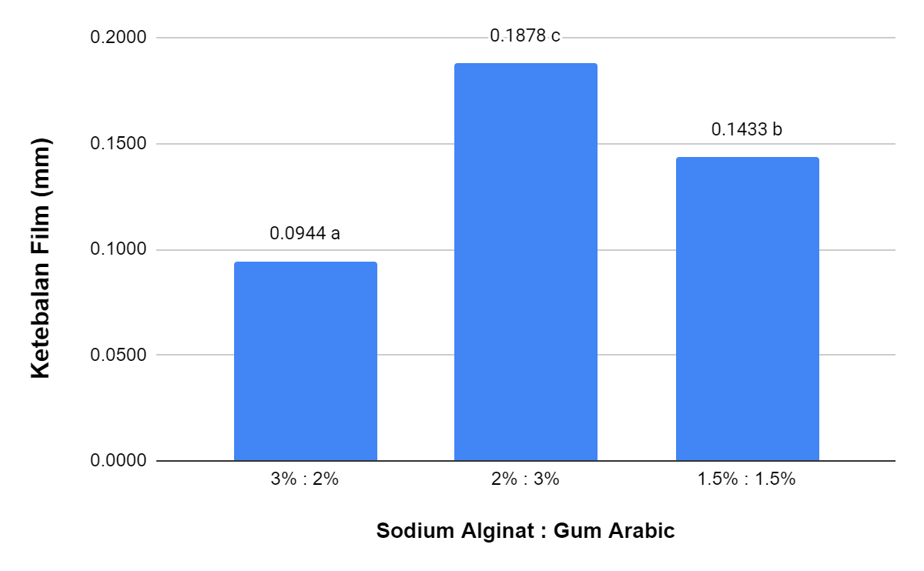

Gambar 1. Ketebalan *Edible Film* Sodium Alginate-Gum Arabic dengan Penambahan Minyak Kayu Manis

Hasil sidik ragam menunjukkan bahwa ratio *sodium alginat* dengan *gum arabic* memberikan pengaruh nyata (F(8,27)= 49.962, P=0,000) terhadap ketebalan *edible film* dan penambahan minyak kayu manis tidak memberikan pengaruh yang nyata (F(8,27)= 0,972, P=0,397) terhadap ketebalan *edible film*. Serta interaksi sodium alginat dengan gum arabic dan minyak kayu manis tidak memberikan pengaruh nyata (F(8,27)= 2.514, P=0,078) terhadap ketebalan *edible film*. Berdasarkan Gambar 1 nilai ketebalan *edible film* yang diperoleh berbeda nyata antara rasio 3%: 2% dan rasio 2% : 3% serta rasio 1.5% : 1.5% sodium alginat : gum arabic tanpa dan dengan penambahan minyak kayu manis.

Ketebalan pada edible film sodium alginate/gum arabic dengan penambahan minyak kayu manis berkisar antara 0,06 mm - 0,20 mm. Ketebalan film tertinggi diperoleh pada 2% sodium alginat : 3% gum arabic dengan minyak kayu manis 15,7 mg/mL sebesar 0,20 mm dan ketebalan film terendah pada perlakuan 3% sodium alginat : 2% gum arabic tanpa penambahan minyak kayu manis. Hasil ketebalan film yang diperoleh sudah memenuhi Standar Industri Jepang (JIS) di mana ketebalan standar maksimum edible film harus di bawah 0,25 mm. *Edible film* yang lebih tebal dapat menghambat transmisi gas selama respirasi, sehingga menyebabkan *off-flavor* pada makanan. Ketebalan film yang sangat penting untuk menjaga kualitas makanan secara optimal, sehingga dapat memperpanjang umur simpan makanan. Hal ini sesuai dengan pernyataan Othman et al. (2022) bahwa film dengan ketebalan yang rendah sangat baik untuk menjaga kualitas produk pangan dan meningkatkan umur simpan bahan makanan.

**III.1.2 Laju Transmisi Uap Air**

Nilai transmisi menunjukkan kejernihan dari film, semakin rendah nilai transparansi, semakin jelas film tersebut. Kemasan edible film diharapkan dapat melindungi bahan pangan dengan menjaga oksigen dan kelembapan di dalam luar kemasan. Nilai laju transmisi uap air yang rendah menunjukan ketahanan dari *edible film* terhadap uap air baik (Dewi, 2021).

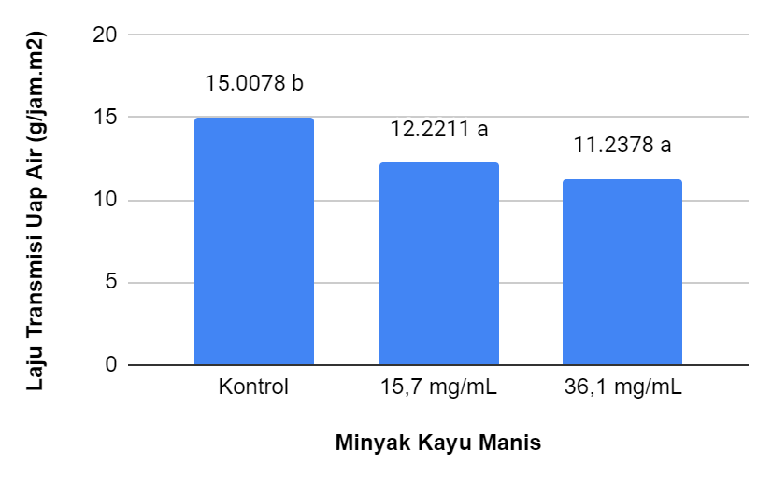

Gambar 2. Laju Transmisi Uap Air *Edible Film* Sodium Alginate-Gum Arabic dengan Penambahan Minyak Kayu Manis

Hasil sidik ragam menunjukkan bahwa ratio *sodium alginat* dengan *gum arabic* tidak memberikan pengaruh nyata (F(8,27)= 0,618, P=0,550) terhadap laju transmisi uap air *edible film* dan penambahan minyak kayu manis memberikan pengaruh yang nyata (F(8,27)= 24.382, P=0,000) terhadap laju transmisi uap air *edible film*. Serta interaksi sodium alginat dengan gum arabic dan minyak kayu manis tidak memberikan pengaruh nyata (F(8,27)= 2.066, P=0,128) terhadap laju transmisi uap air *edible film*. Berdasarkan Gambar 5 menunjukan bahwa nilai laju transmisi uap air *edible film* yang diperoleh tanpa penambahan minyak kayu manis berbeda nyata dengan penambahan minyak kayu manis 15,7 mg/mL dan 36,1 mg/mL.

Laju transmisi uap air yang diperoleh dari *edible film* sodium alginate/gum arabic dengan penambahan minyak kayu manis berkisar antara 1,10 g/jam,m2 - 1,60 g/jam.m2. Nilai laju transmisi uap tertinggi sebesar 1,60 g/jam.m2 didapatkan dari sampel 2% sodium alginat : 3% gum arabic tanpa penambahan minyak kayu manis, sedangkan nilai terendah yaitu sebesar 1,10 g/jam.m2 didapatkan dari sampel 3% sodium alginat : 2% gum arabic minyak kayu manis 36,1 mg/mL. Hal ini menunjukan bahwa penambahan minyak kayu manis memberikan pengaruh terhadap laju transmisi uap air sehingga nilai yang diperoleh rendah. Minyak kayu manis yang bersifat hidrofobik sehingga dapat mengurangi penguapan, degradasi dan oksidasi. Sifat hidrofobik pada minyak kayu manis menyebabkan laju transmisi uap air yang kecil dengan menyeimbakan polimer pada *edible film*. Hal ini sesuai dengan pernyataan Santoso et al. (2018), bahwa edible film yang bersifat hidrofobik sulit untuk ditembus uap air sehingga menjaga kestabilan matrik e*dible film*.

**III.1.3 Daya Larut Air**

Daya larut air pada *edible film* merupakan faktor yang sangat penting sebagai kemasan produk pangan. Kelarutan dipengaruhi oleh komponen hidrofilik atau hidrofobik sebagai bahan utama pembuatan edible film. Nilai kelarutan yang rendah pada edible film sangat baik digunakan sebagai bahan pengemas (Ulfah, 2017).

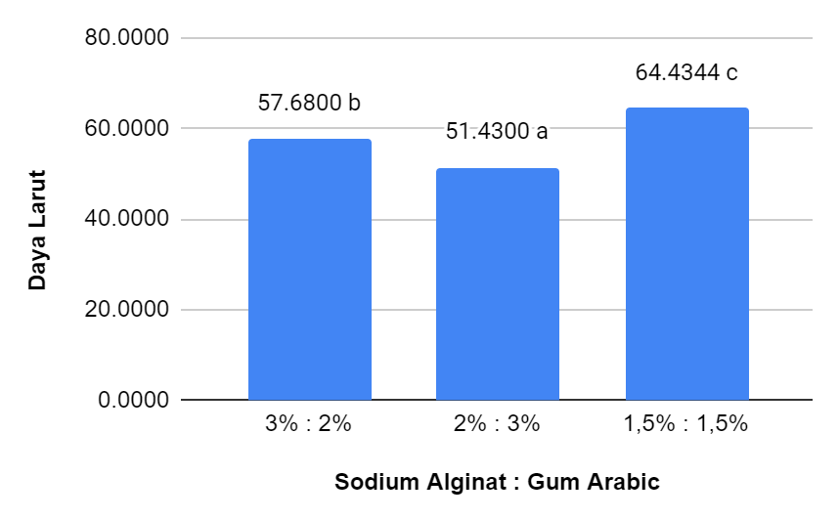

Gambar 3. Daya Larut Air *Edible Film* Sodium Alginate/Gum Arabic dengan Penambahan Minyak Kayu Manis

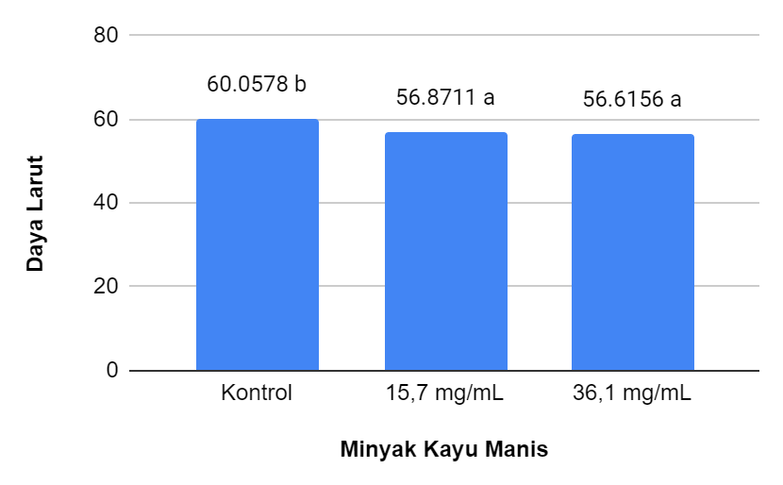

Gambar 4. Daya Larut Air *Edible Film* Sodium Alginate/Gum Arabic dengan Penambahan Minyak Kayu Manis

Hasil sidik ragam menunjukkan bahwa ratio *sodium alginat* dengan *gum arabic* memberikan pengaruh nyata (F(8,27)= 47.759, P=0,000) terhadap daya larut air *edible film* dan penambahan minyak kayu manis memberikan pengaruh yang nyata (F(8,27)= 4.153, P=0,033) terhadap daya larut air *edible film*. Serta interaksi sodium alginat dengan gum arabic dan minyak kayu manis memberikan pengaruh nyata (F(8,27)= 3.856, P=0,020) terhadap daya larut air *edible film*. Berdasarkan Gambar 3 nilai daya larut air *edible film* dengan rasio sodium alginat dengan gum arabic yang diperoleh berbeda nyata, serta Gambar 4 menunjukan bahwa daya larut air *edible film* tanpa penambahan minyak kayu manis dan dengan penambahan minyak kayu manis 15,7 mg/mL dan 36,1 mg/mL diperoleh hasil berbeda nyata.

Berdasarkan hasil daya larut didapatkan nilai tertinggi sebesar 65,50% pada perlakuan 1,5% sodium alginat : 1,5% gum arabic dengan minyak kayu manis 36,1 mg/mL. Sedangkan nilai terendah sebesar 47,93% pada perlakuan 2% sodium alginate : 3% gum arabic dengan minyak kayu manis 36,1 mg/mL. Hasil daya larut yang diperoleh menunjukan bahwa perbedaan rasio pada sodium alginat dan gum arabic serta penambahan minyak kayu manis mempengaruhi nilai daya larut dari *edible film* dan penambahan minyak kayu. Hal ini dikarenakan interaksi minyak kayu manis yang bersifat hidrofobik menghalangi film dengan air sehingga menyebabkan kelarutan pada *edible film* menurunnya. Hal ini sesuai dengan pernyataan Sylviana et al. (2018) bahwa film yang mengandung minyak esensial akan sulit untuk larut dikarenakan terdegradasi oleh air dibandingkan dengan *edible film* tanpa minyak esensial.

**III.1.4 Kuat Tarik**

Kuat tarik merupakan sifat mekanik pada *edible film* yang sangat penting untuk menentukan karakteristik karena kekuatan tarik film tinggi dapat melindungi produk pangan yang dikemas. Ikatan yang terjadi antarmolekul akan meningkatkan kekuatan tarik suatu film. Nilai kuat tarik yang rendah menunjukkan bahwa film tersebut mudah rusak sedangkan nilai yang tinggi mengindikasikan film dapat melindungi produk dari gangguan mekanik berupa gesekan maupun benturan terhadap produk (Nanda, 2018).

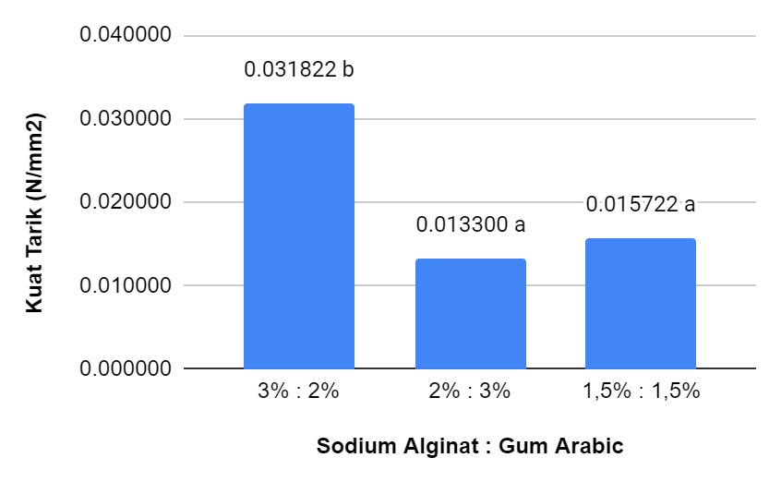

Gambar 5. Kuat Tarik *Edible Film* Sodium Alginate/Gum Arabic dengan Penambahan Minyak Kayu Manis

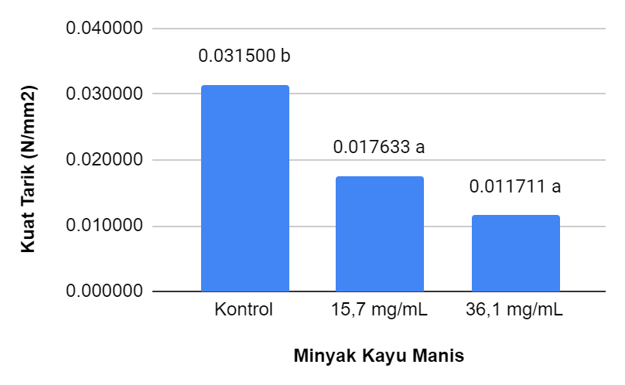

Gambar 6. Kuat Tarik *Edible Film* Sodium Alginate/Gum Arabic dengan Penambahan Minyak Kayu Manis

Hasil sidik ragam menunjukkan bahwa ratio *sodium alginat* dengan *gum arabic* memberikan pengaruh nyata (F(8,27)= 22.264, P=0,000) terhadap kuat tarik *edible film* dan penambahan minyak kayu manis memberikan pengaruh yang nyata (F(8,27)= 22.660, P=0,000) terhadap kuat tarik *edible film*. Serta interaksi sodium alginat dengan gum arabic dan minyak kayu manis memberikan pengaruh nyata (F(8,27)= 15.355, P=0,000) terhadap kuat tarik *edible film*. Berdasarkan Gambar 5 dan Gambar 6 nilai kuat tarik *edible film* rasio sodium alginate/gum arabic dengan variasi minyak kayu manisyang diperoleh berbeda nyata.

Kuat tarik yang diperoleh dari *edible film* rasio sodium alginate/gum arabic dengan variasi konsentrasi minyak kayu manis berkisar antara 0,0070 N/mm2 - 0,0620 N/mm2. Nilai kuat tarik tertinggi pada perlakuan 3% sodium alginat : 2% gum arabic tanpa minyak kayu manis sebesar 0,0620 N/mm2 sedangkan nilai kuat tarik terendah sebesar 0,0070 N/mm2 pada perlakuan 2% sodium alginat : 3% gum arabic dengan minyak kayu manis 36,1 mg/mL. Hal ini menunjukan bahwa penambahan minyak kayu manis yang meningkat menyebabkan berkurangnya interaksi antar molekul bahan penyusun *edible film*. Hal ini sesuai dengan pernyataan Sholehah et al. (2016) bahwa penambahan minyak atsiri akan memperlemah jaringan antar film, sehingga semakin banyak minyak atsiri yang ditambahkan pada film maka matriks yang terbentuk akan lebih rapuh karena minyak memiliki ikatan antara senyawa yang lemah.

**III.2 Penelitian Tahap Kedua**

Pada penelitian ini tahap kedua yang dilakukan yaitu mengaplikasikan satu perlakuan terbaik edible film pada fillet daging sapi berdasarkan nilai terendah pada laju transmisi uap air. Hasil terbaik yaitu rasio 1,5% sodium alginat : 1,5% gum Arabic dengan penambahan 36,1 mg/mL minyak kayu manis. Proses penyimpanan fillet daging sapi dilakukan selama 8 hari kemudian dilakukan pengujian *total plate count, total volatile base nitrogen*, pH, warna, dan analisa sensori. Pengujian daya hambat mikroba yang dilakukan dengan membandingkan sampel edible film yang menggunakan minyak kayu manis dan tanpa menggunakan minyak kayu manis. Tujuan dilakukan penelitian tahap kedua ini untuk mengetahui efektifitas dari minyak kayu manis pada edible film terhadap daya hambat mikroba dan perubahan kesegaran daging selama proses penyimpanan. Berdasarkan hasil yang diperoleh bahwa edible film berbahan dasar sodium alginat : gum arabic dengan konsentrasi yang sama memiliki kemampuan struktur dari biopolimer dalam kombinasi dengan jenis dan jumlah *plasticizing* (Thakhiew, 2010).

**III.2.1 Aktivitas Antimikroba**

Aktivitas antimikroba pada edible film untuk mengetahui efektivitas minyak atsiri yang ditambahkan ke dalam edible film yang berfungsi mengontrol pertumbuhan mikrobiologi dan memperpanjang umur simpan. Minyak atsiri kayu manis telah menunjukkan aktivitas antimikroba spektrum tinggi dan luas dan menunjukkan penghambatan jamur yang hebat (Chao et al., 2000).

**Tabel 1. Nilai Daya Hambat Mikroba Edible Film**

|  |  |  |
| --- | --- | --- |
| Edible Film | Zona Hambat Mikroba (mm) | |
| E. Coli | S. Aureus |
| 1.5% Sodium Alginat : 1.5% Gum Arabic dan Tanpa  Minyak Kayu Manis | 0 | 0 |
| 1.5% Sodium Alginat : 1.5% Gum Arabic dan 36,1  mg/mL Minyak Kayu Manis | 15,41 | 16,51 |

Hasil yang diperoleh nilai daya hambat mikroba pada edible film yang dihasilkan menunjukan bahwa diameter zona hambat terhadap bakteri Escherichia coli relatif lebih rendah dibandingkan dengan diameter zona hambat edible film terhadap bakteri Staphylococcus aureus. Berdasarkan tabel 2. Menunjukan bahwa edible film dengan penambahan minyak kayu manis 36,1 mg/mL memiliki efektifitas yang baik dalam menghambat pertumbuhan mikroba. Hasil nilai daya hambat mikroba yang menunjukan terbentuknya zona hambat bening pada bakteri Escherichia coli sebesar 15,40 mm dan pada bakteri Staphylococcus aureus sebesar 16,61. Perbedaan nilai daya hambat mikroba antara bakteri E. coli dan S. aureus dapat disebabkan karena karakteristik dinding sel antara kedua bakteri tersebut. E. coli hanya memiliki satu dinding, sedangkan S. aureus memiliki dinding sel yang berlapis-lapis.

Minyak kayu manis dikenal sebagai komponen bioaktif utama yang memiliki aktivitas antibakteri yang signifikan terhadap S. Aureus dan E. Coli. Minyak kayu manis mengandung senyawa fenolik yang menyerang membran sel karena sifat hidrofobiknya yang menyebabkan penipisan kandungan sel (Nabavi et al., 2015). Bakteri gram positif seperti S. aureus lebih sensitif terhadap minyak atsiri dibandingkan bakteri Gram negatif seperti E. coli. Hal ini disebabkan adanya membran luar yang mengelilingi lapisan peptidoglikan bakteri Gram negatif. Lipopolisakarida membran luar bakteri Bakteri gram negatif membatasi difusi senyawa hidrofobik, mencegah akumulasi minyak atsiri pada membran, sehingga diperlukan konsentrasi minyak atsiri yang lebih tinggi untuk menghambat pertumbuhan bakteri gram negatif. Mekanisme aktivitas penghambatan mikroba berhubungan dengan kemampuan senyawa fenolik untuk mengubah permeabilitas sel mikroba, merusak membran sitoplasma, mengganggu sistem pembangkit energi seluler (ATP), dan mengganggu kekuatan gerak proton. Oleh karena itu, permeabilitas membran sitoplasma yang terganggu akan menyebabkan kematian sel (Calo et al., 2015).

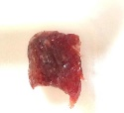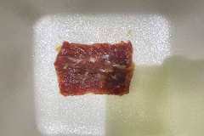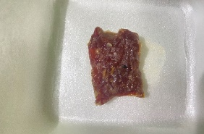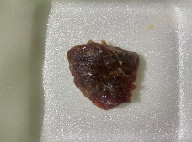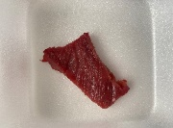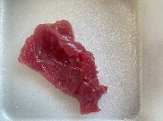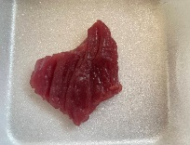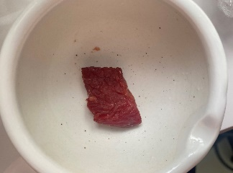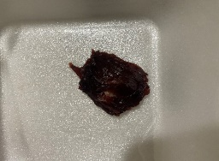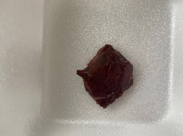

**III.2.2 *Total Plate Count***

Total Plate Count (TPC) merupakan metode yang umum digunakan untuk menghitung jumlah koloni mikroba pada suatu sampel dalam media agar. Nilai TPC yang semakin besar menggambarkan keberadaan mikroba pada sampel yang sudah tercemar. Daging salah satu produk pangan yang mudah terkontaminasi oleh mikroorganisme sehingga memungkinkan untuk terjadinya *foodborne disease* pada manusia. Bakteri pada bahan pangan yang tercemar dapat menimbulkan penyakit apabila keberadaannya berada di atas ambang batas yang diperbolehkan.

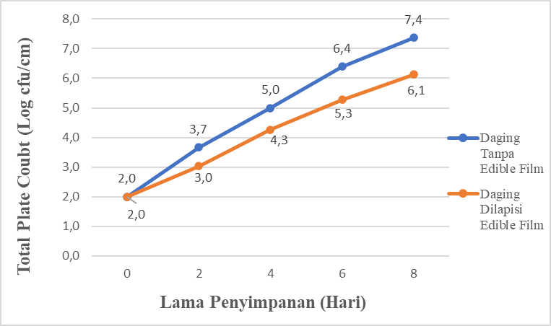

Gambar 7. *Total Plate Count* *Edible Film* Sodium Alginate-Gum Arabic dengan Penambahan Minyak Kayu Manis

Hasil yang diperoleh pada pengujian Total Plate Count yaitu nilai TPC fillet daging sapi tanpa edible film berkisar antara 2 - 7,4 log10 cfu/cm2 sedangkan nilai TPC fillet daging sapi dilapisi edible film berkisar antara 2 - 6,1 log10 cfu/cm2. Berdasarkan hasil yang diperoleh nilai TPC menunjukan peningkatan jumlah mikroba pada fillet daging sapi selama penyimpanan hari ke-0 hingga hari ke-8. Hasil uji paired test menunjukan selama penyimpanan fillet daging sapi tanpa edible film dan fillet daging sapi yang dilapisi dengan edible film menunjukan hasil yang berbeda nyata pada hari ke-2 hingga hari ke-8. Standar maksimum nilai TPC pada daging sapi berdasarkan standar regulasi dari *European Commission* (EC) 2073/2005 yang dapat diterima yaitu <5 log10 cfu/cm2. Peningkatan nilai total mikroba lebih signifikan pada fillet daging sapi tanpa dilapisi edible film jika dibandingkan dengan fillet daging sapi dilapisi edible film. Hal ini menunjukan bahwa pengaplikasian edible film dengan penambahan minyak kayu manis dapat menghambat pertumbuhan mikroba yang dapat menyebabkan kerusakan pada daging sapi. Edible film dapat berfungsi sebagai penghalang terhadap perpindahan oksigen, air, dan kehilangan aroma volatil dari produk pangan (Tapia et al., 2007).

Penggunaan minyak kayu manis pada edible film memberikan peran dalam menghambat pertumbuhan mikroba pada fillet daging sapi. Hal ini dikarenakan kandungan senyawa aktif mayoritas eugenol yang terdapat dalam minyak atsiri dan oleoresin kayu manis dapat berfungsi sebagai antimikroba dan antioksidan (Singh et al., 2007). Penggunaan kemasan edible film yang mengandung senyawa antimikroba efisien untuk mengatur proses migrasi bahan aktif ke dalam daging sapi. Hasil TPC fillet daging sapi terjadi peningkatan jumlah mikroba hal ini sebanding dengan lama waktu penyimpanan. Menurut (Samudra,2016) kontaminasi awal yang terjadi diduga disebabkan karena proses awal pemotongan yang dilakukan di Rumah Potong Hewan (RPH) yang kurangnya sanitasi pada saat proses pemotongan sehingga daging sapi tercemar mikroba. Kemasan yang mengandung antimikroba dapat melindungi daging dari kontaminasi patogen dengan mencegah pertumbuhan mikroba melalui kontak langsung kemasan dengan permukaannya. Hal ini sesuai dengan pernyataan (Khare, 2016) bahwa nilai TPC memiliki kecenderungan meningkat selama masa penyimpanan, namun daging yang dilapisi dengan edible film yang mengandung minyak kayu manis memiliki nilai yang lebih rendah dibandingkan dengan kontrol.

**III.2.3 Total Volatile Base Nitrogen**

Analisis total volatile basic nitrogen (TVB-N) merupakan hasil dari degradasi protein dan senyawa lain yang mengandung nitrogen sebagai akibat dari mekanisme pembusukan tersebut di atas menyebabkan akumulasi amina organik. Senyawa ini beracun dan menyebabkan perubahan warna dan rasa yang cukup besar yang dapat mempengaruhi daya terima produk daging. (Wang, 2019).

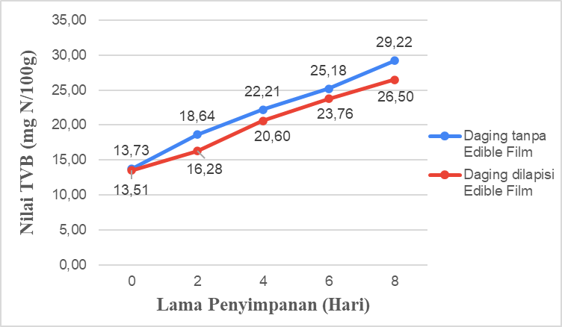

Gambar 8. Nilai TVB-N Pada Fillet Daging Sapi Selama Penyimpanan

Pada Gambar 18 menunjukkan terjadi kenaikan nilai TVB-N pada fillet daging sapi tanpa dilapisi edible film dan dilapisi edible film. Nilai TVB-N pada fillet daging sapi tanpa dilapisi edible film meningkat dari 15,99 N/100 g menjadi 36,22 N/100 g, fillet daging sapi dilapisi edible film meningkat dari 16,18 N/100 g menjadi 30,50 N/100 g. Nilai TVB-N fillet daging tanpa dilapisi edible film secara signifikan mengalami kenaikan yang lebih tinggi daripada fillet daging dilapisi edible film. Berdasarkan hasil yang diperoleh penggunaan edible film dengan penambahan minyak kayu manis pada fillet daging dapat menghambat kebusukan yang terjadi pada fillet daging sapi. Hasil analisis sidik ragam menunjukkan bahwa fillet daging sapi yang diaplikasikan dengan edible film memiliki nilai sig (2-tailed) yaitu 0,012 maka terdapat perbedaan yang signifikan pada nilai TVB-N.

Peningkatan nilai TVB-N pada fillet daging dapat terjadi dikarenakan perombakan molekul protein yang menyebabkan kebusukan sehingga jumlah total nitrogen meningkat. Semakin lama penyimpanan dapat meningkatkan nilai total mikroba pada fillet daging sehingga terjadinya degradasi protein yang berlangsung lebih cepat yang berbanding lurus dengan jumlah amonia dan senyawa volatil sebagai indikator kebusukan. Penetapan kandungan TVB-N sebagai indeks kesegaran pada daging dengan penggunaannya dalam pengukuran kualitas makanan. Menurut Kasmadiharja (2008) nilai TVB-N menandakan daging mulai busuk sebesar 20-30 mg N/100 g, dan daging telah busuk sebar 30 mg N/100 g.

**III.4 Warna**

Warna salah satu karakteristik penting untuk menentukan kualitas yang mencerminkan sifat fungsional dan teknologi daging. Warna adalah aspek yang penting karena salah satu bagian mendasar dalam produk daging karena perannya sebagai pematangan atau kesegaran suatu produk. Aplikasi *edible film* pada permukaan daging diharapkan dapat meningkatkan stabilitas warna daging merah (Ahmad, 2012). Intensitas pada warna terbagi menjadi tingkat kecerahan, tingkat kemerahan, dan tingkat kekuningan dengan sistem L*, a*, b* (Weaver, 1996).

**III.4.1 Nilai Koordinat L\***

Nilai koordinat L* memiliki nilai 0 (hitam) sampai dengan 100 (putih) yang menyatakan bahwa warna atau cahaya pada daging yang akan muncul atau pantul menghasilkan warna akromatik putih, abu-abu dan hitam. Hasil analisis sidik ragam berdasarkan tabel output paired sample test menunjukkan bahwa fillet daging yang diaplikasikan dengan edible film memiliki nilai sig (2-tailed) yaitu 0,779 maka tidak terdapat perbedaan rata-rata antara kontrol dan perlakuan daging sapi yang dilapisi edible film. Hasil analisis paired test warna fillet daging sapi setelah proses penyimpanan terhadap warna (notasi L*).

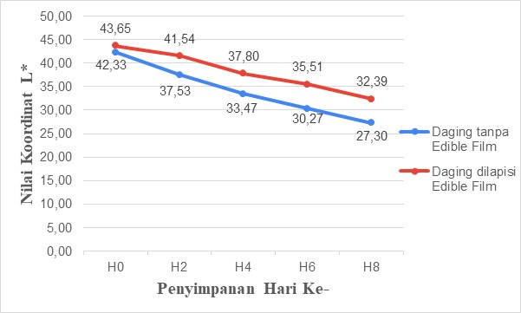

Gambar 9. Warna Fillet daging sapi selama penyimpanan pada Koordinat L*

Fillet daging sapi yang dilapisi dengan edible film yang disimpan pada suhu refrigerator memiliki nilai L* dengan kisaran yaitu 43,65 pada hari ke-0 hingga 32.39 pada hari ke-8. Fillet daging sapi yang disimpan pada refrigerator tanpa menggunakan edible film memiliki nilai L* dengan kisaran yaitu 42,33 pada hari ke-0 hingga 27,30 pada hari ke-8. Hasil tingkat kecerahan (L*) pada fillet daging sapi menunjukkan nilai yang menurun seiring dengan lamanya penyimpanan. Semakin lama waktu penyimpanan fillet daging sapi maka semakin rendah tingkat kecerahan daging sapi tersebut. Hal ini dikarenakan warna daging yang merah kecoklatan mulai mengalami pembusukan sehingga menunjukkan pertumbuhan mikrobiologi. Adanya perubahan warna yang terjadi pada daging selama penyimpanan seiring dengan peningkatan nilai pH. Pigmen mioglobin pada daging memiliki fungsi untuk menyimpan oksigen sedangkan hemoglobin sebagai transport oksigen. Berdasarkan hasil yang diperoleh menunjukan bahwa nilai L* pada daging sapi tanpa menggunakan kemasan edible film mengalami penurunan yang sangat signifikan jika dibandingkan daging sapi yang menggunakan kemasan edible film. Hal ini sesuai dengan pernyataan (Sembiring et al., 2015) bahwa tingkat kecerahan pada daging sapi yang semakin menurun selama penyimpanan dikarenakan daging mengalami proses pembusukan sehingga terjadi reduksi pigmen daging menjadi metmioglobin.

**IV.3.4.2 Nilai Koordinat a\***

Nilai koordinat a* yang positif menunjukkan warna pada sampel merah. Sedangkan nilai negatif menunjukkan warna pada sampel hijau. Hasil analisis sidik ragam berdasarkan tabel output paired sample test menunjukkan bahwa daging yang diaplikasikan dengan edible film memiliki nilai sig (2-tailed) yaitu 0,014 maka terdapat perbedaan rata-rata antara kontrol dan perlakuan. Hasil analisis paired tes warna fillet daging sapi setelah proses penyimpanan terhadap warna (notasi a*)

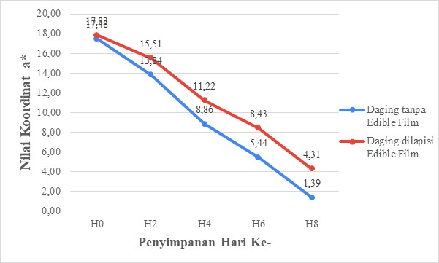

Gambar 10. Warna Fillet daging sapi selama penyimpanan pada Koordinat titik a*

Fillet daging sapi yang dilapisi dengan edible film yang disimpan pada suhu refrigerator memiliki nilai a* dengan kisaran yaitu 17,83 pada hari ke-0 hingga 4,31 pada hari ke-8. Fillet daging sapi yang disimpan pada refrigerator tanpa menggunakan edible film memiliki nilai a* dengan kisaran yaitu 17,48 pada hari ke-0 hingga 1,39 pada hari ke-8. Tingkat warna hijau-merah (a*) pada fillet daging sapi menunjukkan nilai yang menurun seiring dengan lamanya penyimpanan. Berdasarkan hasil yang diperoleh nilai a* pada daging yang tidak dilapisi edible film lebih rendah dibandingkan dengan daging sapi yang dilapisi dengan edible film selama penyimpanan dengan suhu refrigerator. Daging sapi segar pada umumnya menjadi kurang merah setelah penyimpanan beberapa hari. Paparan pencahayaan karena mioglobin dan oksimioglobin dengan oksigen mengarah pada pembentukan metmioglobin, pigmen yang mengubah daging menjadi merah kecoklatan. Hal ini menunjukan bahwa daging sapi yang dilapisi dengan edible film selain mampu mengurangi oksidasi lipid, dapat berperan dalam mempertahankan warna daging sapi. Hal ini sesuai dengan pernyataan (Alexandre et al., 2020) bahwa daging sapi yang dilapisi dengan edible film dapat mengurangi atau menghambat proses degradasi selama penyimpanan daging.

**IV.3.4.3 Nilai Koordinat b\***

Nilai koordinat b* merupakan notasi menyatakan bahwa warna atau cahaya pada daging yang akan muncul dari warna kromatik campuran dari warna biru hingga kuning. Hasil analisis sidik ragam berdasarkan tabel output paired sample test menunjukkan bahwa daging yang diaplikasikan dengan edible film memiliki nilai sig (2-tailed) yaitu 0,008 maka terdapat perbedaan rata-rata antara kontrol dan perlakuan. Hasil analisis paired tes warna fillet daging sapi setelah proses penyimpanan terhadap warna (notasi b*)

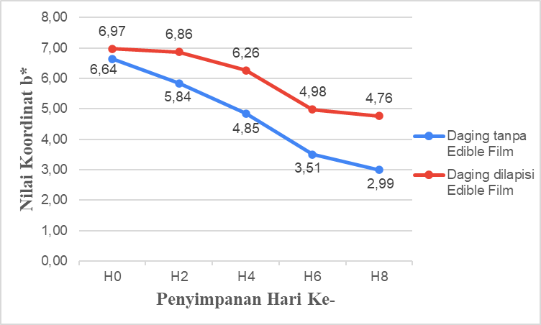

Gambar 11. Warna Fillet daging sapi selama penyimpanan pada Koordinat titik b*

Fillet daging sapi yang dilapisi dengan edible film yang disimpan pada suhu refrigerator memiliki nilai koordinat b* dengan kisaran yaitu 6,97 pada hari ke-0 hingga 4,76 pada hari ke-8. Fillet daging sapi yang disimpan pada refrigerator tanpa menggunakan edible film memiliki nilai a* dengan kisaran yaitu 6,64 pada hari ke-0 hingga 2,99 pada hari ke-8. Tingkat warna biru-kuning (b*) pada fillet daging sapi menunjukkan nilai yang menurun seiring dengan lamanya penyimpanan. Hal ini menunjukan bahwa daging yang dilapisi edible film dapat melindungi daging dari perubahan warna yang lebih besar dibandingkan dengan daging tanpa menggunakan edible film. Penurunan nilai warna pada fillet daging sapi yang dilapisi dengan edible film menunjukkan penurunan yang minimal. Produk pangan segar rentan terhadap kerusakan yang cepat daripada makanan industri. Hal ini sesuai dengan pernyataan (Yousefi, 2018) bahwa daging sapi yang dikemas dalam film biodegradable memiliki warna yang lebih cerah, karena kemasan yang diusulkan mencegah oksidasi pigmen hemoglobin.

**IV.3.5 pH**

Tingkat keasaman (pH) merupakan indeks kualitas daging yang paling penting karena digunakan dalam evaluasi standar daging dan terutama dalam memilih daging untuk proses penuaan. Parameter kualitas pada daging yang tidak tepat terutama pH tinggi, yang secara negatif mempengaruhi sifat teknologinya dan membatasi kesesuaiannya untuk produksi daging kuliner (Węglarz et al., 2002; Kögel, 2005). Hasil analisis sidik ragam berdasarkan tabel output paired sample test menunjukkan bahwa daging yang diaplikasikan dengan edible film memiliki nilai sig (2-tailed) yaitu 0,084 maka terdapat perbedaan pH antara kontrol dan perlakuan.

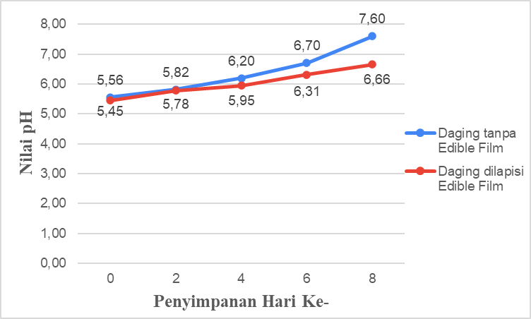

Gambar 12. pH Fillet daging sapi selama penyimpanan

Berdasarkan hasil yang didapatkan bahwa pH pada fillet daging sapi yang dilapisi menggunakan edible film berkisar antara 5,45 pada hari ke-0 hingga 6,66 pada hari ke-8. Fillet daging sapi yang tidak menggunakan edible film berkisar antara 5,56 pada hari ke-0 hingga 7,60 pada hari ke-8. Nilai pH yang semakin meningkat secara bertahap selama periode penyimpanan memiliki dampak yang negatif pada kualitas daging sapi selama penyimpanan, terutama dalam hal sensori termasuk bau, warna, dan tekstur. Faktor yang mempengaruhi nilai pH dan umur simpan dari daging sapi setelah pemotongan dan selama penyimpanan adalah pembusukan mikroba, oksidasi lipid dan pembusukan enzimatik autolitik (Dave dan Ghaly, 2011). Korelasi antara pH daging yang semakin tinggi dan parameter warna yang semakin menurun. Daging sapi yang dikemas menggunakan edible film memiliki efek dalam meningkatkan kandungan antimikroba dan kualitas daging sapi yang lebih terjaga berdasarkan nilai pH dan warna jika dibandingkan dengan daging sapi tanpa dilapisi dengan edible film. Hal ini sesuai dengan pernyataan (Węglarz, 2010) bahwa daging sapi berkualitas tinggi memiliki pH tertinggi pada kisaran 5,4–5,6, sehingga pada pH > 5,8 terjadi penurunan mutu daging.

**IV.3.6 Analisis Sensori**

Analisis sensori adalah metode yang digunakan untuk mengetahui atribut sensori pada suatu produk atau bahan pangan. Parameter pada analisis sensori pada daging antara lain tekstur, warna, dan aroma. Analisa sensori memiliki relevansi terhadap mutu pada bahan pangan karena berhubungan dengan tingkat kesukaan konsumen (Rohim, 2015).

**Tabel 2. Nilai Organoleptik Fillet Daging Sapi Selama Penyimpanan**

|  |  |  |  |  |
| --- | --- | --- | --- | --- |
| **Penyimpanan Hari Ke** | **Perlakuan** | **Pengujian** | | |
| **Aroma** | **Warna** | **Tekstur** |
| 1 | Tanpa Edible Film | 4,07 | 3,78 | 3,78 |
| Dilapisi Edible Film | 4,62 | 4,38 | 4,44 |
| 2 | Tanpa Edible Film | 3,33 | 2,89 | 2,89 |
| Dilapisi Edible Film | 3,96 | 4,11 | 3,76 |
| 3 | Tanpa Edible Film | 2,40 | 2,78 | 2,78 |
| Dilapisi Edible Film | 3,64 | 3,62 | 3,36 |
| 4 | Tanpa Edible Film | 1,93 | 2,42 | 2,42 |
| Dilapisi Edible Film | 3,11 | 2,73 | 2,69 |
| 5 | Tanpa Edible Film | 1,49 | 1,60 | 1,40 |
| Dilapisi Edible Film | 2,71 | 2,42 | 2,47 |

Berdasarkan Tabel 2. diperoleh bahwa rata-rata tingkat kesukaan panelis terhadap parameter aroma pada fillet daging sapi yang dilapisi menggunakan edible film yaitu berkisar antara 4,62 pada hari ke-0 hingga 2,71 pada hari ke-8. Sedangkan hasil rata-rata tingkat kesukaan panelis terhadap parameter warna pada fillet daging sapi yang dilapisi menggunakan edible film yaitu berkisar antara 4,38 pada hari ke-0 hingga 2,42 pada hari ke-8. Nilai rata-rata tingkat kesukaan panelis terhadap parameter tekstur pada fillet daging sapi yang dilapisi menggunakan edible film yaitu berkisar antara 4,44 pada hari ke-0 hingga 2,47 pada hari ke-8.

Hasil analisis sidik ragam berdasarkan tabel output paired sample test menunjukkan bahwa nilai organoleptik aroma memiliki nilai sig (2-tailed) yaitu 0,113 maka tidak terdapat perbedaan yang signifikan pada nilai organoleptik aroma antara daging tanpa edible film dan daging dilapisi edible film. Hasil analisis sidik ragam berdasarkan tabel output paired sample test menunjukkan bahwa nilai organoleptik warna memiliki nilai sig (2-tailed) yaitu 0,008 maka terdapat perbedaan yang signifikan pada nilai organoleptik warna antara daging tanpa edible film dan daging dilapisi edible film. Hasil analisis sidik ragam berdasarkan tabel output paired sample test menunjukkan bahwa nilai organoleptik tekstur memiliki nilai sig (2-tailed) yaitu 0,016 maka terdapat perbedaan yang signifikan pada nilai organoleptik tekstur antara daging tanpa edible film dan daging dilapisi edible film.

Penggunaan edible film pada daging terdeteksi oleh indera penciuman panelis karena edible film menggunakan minyak kayu manis sehingga aroma kayu manis lebih mendominasi dibandingkan aroma daging. Hal ini sesuai dengan pernyataan (El-Zainy 2014) bahwa lama penyimpanan menyebabkan penurunan sifat organoleptik terutama aroma yang disebabkan oleh penurunan sifat mikrobiologi dan kimia selama penyimpanan. Hasil penilaian panelis terhadap warna fillet daging sapi disebabkan karena terjadinya perubahan warna fillet daging sapi selama penyimpanan antara daging sapi tanpa edible film dengan daging sapi dilapisi edible film. Semakin lama masa simpan daging sapi yang dilapisi edible film dengan penambahan minyak kayu manis menyebabkan akan semakin berwarna merah gelap cenderung merah kecoklatan jika dibandingkan dengan daging tanpa edible film warna yang lebih tua merah kecoklatan. Menurut Lawrie (2003), warna pada daging sapi dipengaruhi oleh besarnya kandungan mioglobin yang terkandung di dalamnya sehingga warna yang lebih gelap menunjukkan kandungan mioglobin yang lebih banyak. Selain itu, penurunan nilai tekstur juga dipengaruhi oleh kadar air, dimana pada daging yang dikemas memiliki kadar air tinggi sehingga terjadinya perubahan kadar air yang pada akhirnya berpengaruh pada kekerasan bahan pangan. Hal ini sesuai dengan pernyataan (Soladoye, 2015) bahwa modifikasi kimia yang paling relevan, pembentukan ikatan silang protein dan karbonilasi protein telah dikaitkan dengan hilangnya fungsionalitas protein otot dan modifikasi atribut daging seperti warna, rasa dan tekstur.

**BAB IV. PENUTUP**

**IV.1 Kesimpulan**

Berdasarkan hasil penelitian dan pembahasan, maka dapat ditarik beberapa kesimpulan sebagai berikut :

1. Formulasi rasio terbaik edible film sodium alginat:gum arabic terhadap sifat fisik mekanik diperoleh dari perlakuan 1,5% sodium alginat : 1,5% gum arabic dengan penambahan minyak kayu manis 36,1 mg/mL.
2. Edible film dengan penambahan minyak kayu manis sebesar 36,1 mg/mL terhadap total plate count fillet daging sapi mampu menghabat pertumbuhan mikroba, serta terhadap total volatil base nitrogen mampu menghambat kebusukan yang terjadi pada fillet daging sapi, dan terhadap daya hambat mikroba mampu menghambat bakteri *Escherichia coli* sebesar 15,40 mm dan pada bakteri *Staphylococcus aureus* sebesar 16,61 mm.

**IV.2 Saran**

Saran untuk penelitian selanjutnya sebaiknya perlu dilakukan penelitian lebih lanjut mengenai pengaplikasian pada produk pangan lainnya untuk mengetahui efektivitas edible film selain untuk fillet daging sapi.

**DAFTAR PUSTAKA**

Ahmad, A., Mubarak, N. M., Jannat, F. T., Ashfaq, T., Santulli, C., Rizwan, M., Najda, A., Jumah, M. B. 2021. A Critical Review on the Synthesis of Natural Sodium Alginate Based Composite Materials: An Innovative Biological Polymer for Biomedical Delivery Applications. Journal Processes. 9(137):1-27

Calo, J. R., Crandall, P. G., O’Bryan, C. A., & Ricke, S. C. (2015). Essential oils as antimicrobials in food systems - A review. Food Control, 54, 111–119. <https://doi.org/10.1016/j.foodcont.2014.12.040>

Chao, S. C., Young, D. G., & Oberg, C. J. (2000). Screening for inhibitory activity of essential oils on selected bacteria, fungi and viruses. Journal of Essential Oil Research, 12(5), 639–649. <https://doi.org/10.1080/10412905.2000.9712177>

Dewi, R., Rahmi. dan Nasrun. 2021. Perbaikan Sifat Mekanik Dan Laju Transmisi Uap Air Edible Film Bioplastik Menggunakan Minyak Sawit Dan Plasticizer Gliserol Berbasis Pati Sagu. *Jurnal Teknologi Kimia Unimal*. 10(1):61-77.

El-Zainy, A.R.M., Aboul-Anean, H.E., Shelbaya L.A., Ramadan E.M.M. 2014. Effect of Edible Coating with Cinnamon Oil on the Quality of Cake. *Middle East Journal of Applied Sciences*. 4(4): 1171-1186.

Khare, A.K., Abraham, R.J.J., Rao, V.A., Babu, R.N and Ruban, W. 2016. Effect of Chitosan and Cinnamon oil edible coating on shelf life of chicken fillets under refrigeration conditions. Indian Journal Of Animal Research. 1-8

Kasmadiharja H. 2008. Kajian Penyimpanan Sosis, Naget Ayam dan Daging Ayam Berbumbu Dalam Kemasan Polipropilen Rigid [Skripsi]. Bogor: Fakultas Pertanian, Institut Pertanian Bogor.

Kögel J. (2005): Hereditary and environmental effects on the quality of beef. Animal Science Papers and Reports, 23, 281–302.

Lawrie, R. A. 2003. Ilmu Daging. Edisi 5 Penerjemah Aminuddin Parakkasi. Penerbit Universitas Indonesia, Jakarta

Liu, S., & Gan, L. (2016). Determination of total volatile basic nitrogen (TVB-N) content in beef by hyperspectral imaging technique. Paper presented at the MATEC Web of Conferences.

M. Ahmad, S. Benjakul, P. Sumpavapol, and N. P. Nirmal, “Quality changes of sea bass slices wrapped with gelatin film incorporated with lemongrass essential oil,” International Journal of Food Microbiology, vol. 155, no. 3, pp. 171–178, 2012

Othman, F., Idris, S.N., Nasir, N.A.H.A., dan Nawawi, M.A. 2022. Preparation and Characterization of Sodium Alginate-Based Edible Film with Antibacterial Additive using Lemongrass Oil. *Sains Malaysiana.* 51(2): 485-494.

Sylviana., Kiyat, W.E., Indriyati., dan Srikandace, Y. 2018. Karakterisasi Edible Film Bioselulosa Mengandung Minyak Jeruk Bergamot, dan Aplikasinya pada Enting-Enting Gepuk. *Majalah Polimer Indonesia*. 21(1): 49-68.

Sholehah, M.M., Ma’ruf, W.F., Romadhon. 2016. Karakteristik Dan Aktivitas Antibakteri Edible Film Dari Refined Carrageenan Dengan Penambahan Minyak Atsiri Lengkuas Merah (Alpinia purpurata). J. Peng. & Biotek. Hasil Pi. 5(3):1-8.

Soladoye OP, Juárez ML, Aalhus JL, Shand P, Estévez M (2015) Protein Oxidation in Processed Meat: Mechanisms and Potential Implications on Human Health. Comprehensive Reviews in Food Science and Food Safety 14: 106–122.

Sembiring UR, Suada IK, Agustina KK. 2015. Kualitas Daging Kambing yang Disimpan pada Suhu Ruang Ditinjau dari Uji Subjektif dan Objektif. Indonesia Medicus Veterinus. 4(2): 155-162.

Santoso, B,. Amilita, D., Priyanto, G., Hermanto, dan Sugito. 2018. Pengembangan Edible Film Komposit Berbasis Pati Jagung dengan Penambahan Minyak Sawit dan Tween 20. *J.Agritech*. 38(2): 119-124.

Tapia, M.S., M.A. Rojas-Grau, F.J. Rodriguez, J. Ramirez, A. Carmona, and O. Martin-Belloso. 2007. Alginate- and gellanbased edible films for probiotic coating on fresh cut fruits. J. Food Sci. 72(4): E 190−196

Warkoyo, B., Rahardjo, D.W., Marsono dan Karyadi, J.N.W. 2014. Sifat Fisik, Mekanik Dan Barrier Edible Film Berbasis Pati Umbi Kimpul (Xanthosoma Sagittifolium) Yang Di Korporasi Dengan Kalium Sorbat. Agritech. 34(1):72-81.

Węglarz A., Zapletal P., Gil Z., Skrzyński G., Adamczyk K. (2002): The effect sex and age on beef quality. Zesz. Nauk. Prz. Hod., 62, 211–216. (in Polish, with English summary).

Węglarz, A., 2010. Meat Quality Defined Based On Ph And Colour Depending On Cattle Category And Slaughter Season. *Czech J. Anim. Sci*. 55(12): 548–556

Yousefi, M., Azizi, M., Ehsani, A. 2018. Antimicrobial coatings and films on meats: A perspective on the application of antimicrobial edible films or coatings on meats from the past to future. *Bali Medical Journal*. 7(1): 87-96

**LAMPIRAN**

Lampiran 01. Diagram Alir Prosedur Penelitian



**THE EFFECT OF RATIO SODIUM ALGINATE-GUM ARABIC AND CINNAMON OIL (*Cinnamomum burmannii*) CONCENTRATION ON PHYSICAL, MECHANICAL, AND ANTIMICROBIC PROPERTIES IN EDIBLE FILM**

*The Effect Of Ratio Sodium Alginate-Gum Arabic And Cinnamon Oil (Cinnamomum burmannii) Concentration On Physical, Mechanical, And Antimicrobic Properties In Edible Film*

**BY**

**CLARA NOVELIA JESSICA SULI**

**G031181301**



**FOOD SCIENCE AND TECHNOLOGY STUDY PROGRAM**

**DEPARTMENT OF AGRICULTURAL TECHNOLOGY**

**FACULTY OF AGRICULTURE**

**HASANUDDIN UNIVERSITY**

**MAKASSAR**

**2022**

***THE EFFECT OF RATIO SODIUM ALGINATE-GUM ARABIC AND CINNAMON OIL (Cinnamomum burmannii) CONCENTRATION ON PHYSICAL, MECHANICAL, AND ANTIMICROBIC PROPERTIES IN EDIBLE FILM***

*The Effect Of Ratio Sodium Alginate-Gum Arabic And Cinnamon Oil (Cinnamomum burmannii) Concentration On Physical, Mechanical, And Antimicrobic Properties In Edible Film*

**Andi Tenrimega Tjalo2), Adiansyah Syarifuddin3) Andi Hasizah3)**

**ABSTRACT**

**Background** Edible film is an environmentally friendly primary packaging that can maintain the quality of food products. Edible films are made of three types of constituent materials, including hydrocolloids, lipids, and starch. The addition of cinnamon oil to the edible film can function as an antibacterial agent to preserve the product (food). **The aim** of this study was to determine the concentration of sodium alginate/gum arabic in edible films so as to produce edible films of good quality and characteristics and to determine the best concentration of cinnamon oil as an antimicrobial in edible films. **The method** of this research was to formulate alginate and gum arabic solutions, as well as the edible films with the addition of cinnamon oil as an additive which is then incorporated into edible films and the use/application on meat. **The results** of the first stage test showed that the best treatment obtained based on the mechanical physical properties of the edible film was found in the treatment ratio of 1.5% sodium alginate: 1.5% gum arabic with the addition of cinnamon oil 36.1 mg/mL (thickness 0.014 mm; LTUA 11.15 g/hour.m2; solubility 65.50; tensile strength 0.01 N/mm2). The results of the second stage of the test on edible film with the addition of 36.2 mg/mL of cinnamon oil which was applied to beef had an inhibitory power against gram-negative bacteria (E. coli) of 15.40 mm and gram-positive bacteria (S.aureus). of 16.51 mm, was able to maintain the color and pH of the meat during storage, and was able to inhibit microbial growth on the beef fillet, and organoleptic assessment was still good on beef fillet during storage. **The conclusion** of this study is the ratio of sodium alginate to gum arabic and the addition of cinnamon oil has the potential to improve the physical-mechanical properties of edible films. The addition of cinnamon oil to edible films was able to inhibit gram-positive and negative bacteria from the inhibition zone which was classified as very strong and in its application to beef it was able to maintain color and pH and inhibit microbial growth during storage for 8 days.

*Keywords: Edible film, gum arabic, cinnamon oil, sodium alginate.*

**CHAPTER I. INTRODUCTION**

**I.1 Background**

Edible film is a food packaging material made from environmentally friendly materials because they are renewable. Packaging has a function to protect food from damage and reduce the quality of the food itself. Generally, the packaging uses plastic material because the price is cheap and easy to find. The increased use of plastics can ultimately have a negative impact on the environment, this is because plastic is difficult to recycle (Bao and Hanh, 2008). Along with the development of technology in food, a type of packaging that is biodegradable from edible organic materials has been developed and is less likely to be contaminated in the form of edible film. In addition to being environmentally friendly, edible films can control moisture, oxygen, carbon dioxide, lipids, aroma and taste additives to increase the shelf life of foodstuffs up to several days and can provide better quality food products.

Edible film is an alternative to extend shelf life which acts as a barrier to water vapor, oxygen, and carbon dioxide and as a carrier of substances to inhibit pathogenic microbes and spoilage (Ortega et al., 2014). Edible films are obtained from food-grade filmogenic suspensions which are generally printed on an inert surface, which can be placed in contact with the food surface. Edible films consist of polysaccharides, proteins, and lipids made from various agricultural products and food processing waste and by-products (Huang et al. 2019). Materials that are generally used in the manufacture of edible films are tubers that contain starch. The use of starch as raw material for edible films has the ability to protect the product against oxygen, carbon dioxide, oil, and increase the unity of the product structure. Currently, biopolymer materials such as carbohydrates, chitosan, proteins, lipids, and mixtures are most often used to produce edible films (Ali and Ahmed 2018).

Biopolymer materials such as carbohydrate polymers have better compatibility than proteins and lipid films. This is because amino acids and fatty acids are expensive materials that show poor thermal stability and water solubility, and some of these materials are allergic to humans (Shit and Shah 2014). Sodium alginate which is a beneficial algae-based carbohydrate macromolecule that has potential film-forming properties on hydrolysis and is widely present in cell walls as a mixture of various salts. Sodium alginate film is an anti-microbial factor for improving shelf life quality. Alginate is a product produced from the extraction process of brown seaweed.

Gum arabic is a polysaccharide coating which is widely used due to its good film-forming properties, unique emulsification, encapsulation properties due to its well-known amphiphilic properties. However, there are some applications using gum arabic for coating or film applications and on the other hand, sodium alginate, a polysaccharide extracted mainly from marine algae, exhibits attractive properties for film applications due to its low cost, biocompatibility, biodegradability and good film-forming characteristics. . Gum arabic as an edible film can function as a filler material to produce edible films that have good tensile strength (Santoso et al., 2014). The two polymer phases form a thermally stable and fully miscible amorphous multicomponent system that can be used as a thermally stable polymer material in electronic devices.

Edible film packaging has the ability to protect a food product and the ability as an antimicrobial can stop, inhibit, reduce or slow down the growth of pathogenic microorganisms in food and packaging materials. Therefore, the need for compounds that are hydrophobic so that the characteristics of the resulting edible film are better. Natural antimicrobials can be incorporated into edible film suspensions, adding functionality to edible films and coatings, leading to the acquisition of antimicrobial edible films and coatings. Cinnamon oil is one of the compounds that can be used to balance hydrophilic and hydrophobic polymers on films so as to improve the rate of water vapor transmission that is not good in edible films. The addition of cinnamon oil to edible films can damage the cell walls of microbes and then cause lysis, then kill the microbes found in foodstuffs. So that edible film packaging can increase the shelf life and quality of the product.

Antimicrobial packaging can protect meat from pathogen contamination by preventing microbial growth. Processing of meat from slaughter and processing can lead to microbial growth. According to (M. Ahmad et al. 2012), application of the film on the surface of the meat in some cases can improve the color stability of red meat, but if the coating acts as a gas barrier, unwanted discoloration may occur. Microbes that have developed in meat can cause changes in the quality of meat, including aroma and color changes. Antioxidant compounds used in the polymer matrix can prevent the growth of spoilage and pathogenic microorganisms, delay the rancidity of meat fat, prevent discoloration, and even improve the nutritional quality of layered foods (Soliva-Fortuny et al., 2012). Essential oils generally exhibit higher antibacterial activity than mixtures of major antimicrobial components. Therefore, this study was conducted to determine the effect of adding cinnamon oil on the physical, mechanical, and antimicrobial properties of edible film sodium alginate/gum arabic combination in beef..

**I.2 Problem Formulation**

Edible film is an alternative packaging that is biodegradable that can protect food products from physical, chemical, and biological damage. The raw material for edible film is obtained using a combination of alginate and gum arabic so that it can improve the quality and shelf life of the meat. The addition of cinnamon oil to edible films is therefore necessary to know the physical, mechanical, and antimicrobial properties contained in order to produce a good and suitable edible film.

**I.3 Research Objectives**

The objectives of this research activity are as follows:

1. To determine the right ratio of sodium alginate: gum arabic on edible films so as to produce edible films of good quality and characteristics.
2. To determine the best concentration of cinnamon oil on the physical, mechanical, and antimicrobial properties of edible films.

**I.4 Research Benefits**

The use of this research for researchers, can improve science and technology as well as insight into the physical, mechanical, and antimicrobial properties of making edible films with the addition of cinnamon oil to maintain meat quality and produce edible film packaging with good quality and can be applied to food products.

**II. RESEARCH METHODS**

**III.1 Research Time and Place**

This research will be conducted in September-December at the Product Development Laboratory, Chemical Laboratory of Food Quality Analysis and Control, Food Science and Technology Study Program, Department of Agricultural Technology, Faculty of Agriculture, Hasanuddin University, Makassar.

**III.2 Tools and materials**

The tools that will be used in this research are aluminum foil, beaker glass, bulp, blender, stir bar, petri dish (Normax), chormameter (Minolta CR-300), desiccator, Erlenmeyer, beaker, hot plate (windaus), magnetic stirrer, 150 ml syringe, oven, pH meter, thermometer, test tube, scale, stopwatch, ultra-turrax (T 25 basic) and Universal Testing Machine (Hung Ta, HT2010).

The materials used in this study were distilled water, ammonium hydroxide, ethanol, glycerol, gum arabic, standard solution, 0.1% peptone solution, disc paper, filter paper, cinnamon oil, PCA (Total Plate Agar) media, NaOH (Sodium hydroxide), nutrient agar (NA), sodium alginate, tween 80.

**III.3 Research procedure**

**III.3.1 Preparation of Alginate and Gum Arabic Solution (Nair, 2020)**

0.8 g of sodium alginate and 1.2 g of gum arabic were each added to 40 mL of distilled water, then the two solutions were mixed and stirred with a magnetic stirrer while heated at 80°C for 30 minutes until homogeneous, then 1 M NaOH was added to mix. maintain the pH of the solution.

**III.3.2 Preparation of Gluten Solution (Sharma, 2017)**

Gluten as much as 30 grams was dissolved in 72 mL ethanol then stirred and heated using a magnetic stirrer using a temperature of 75°C for 10 minutes. After that, 48 mL of distilled water and 12 mL of ammonium hydroxide were added to the gluten solution slowly.

III.3.3 Edible Film Production

Sodium alginate/gum arabic solution is mixed with gluten solution and heated at 65°C. Then, 3 g of glycerol was added, 0.6 mL of tween 80, and 0.4 mL of span, then stirred for 10 minutes. Then to each treatment, cinnamon oil was added according to the treatment. The mixture was then homogenized using Ultra-turrax for 2 minutes at a speed of 24,000 rpm. After that, 20 mL of edible film solution, each according to the treatment, was printed using a glass mold. Then the physical and mechanical properties of the edible film were measured, namely the water vapor transmission rate, film thickness, tensile strength and percent elongation as well as the water content of the edible film.

**III.4 Research design**

**III.4.1 Research Phase I**

The first stage of research on the manufacture of edible films with research variables, namely: Factor A: Amount of sodium alginate:gum arabic A1 : 3% sodium alginate: 2% gum arabic

A2 : 2% sodium alginate: 3% gum arabic

A3: 1,5% sodium alginate: 1,5% gum arabic

As well as variations in the concentration of cinnamon oil added to the process of making edible films, namely: Factor B: Cinnamon oil concentration

P1 : control (without adding cinnamon oil)

P2 : Cinnamon oil 15,7 mg/mL

P3 : Cinnamon oil 36,1 mg/mL

Edible movies with the lowest WVTR will be used in the second phase of research.

**III.4.2 Research Phase II**

Fresh beef was sorted, cleaned and then beef samples were cut under aseptic conditions (10 g and boneless), separated into two types of storage, namely control and meat covered with edible film. After that, the beef samples were stored with storage time intervals of 0, 2, 4, 6 and 8 days at refrigerator temperature, then performed microbial analysis (total viable count), changes in beef color before and after storage, pH and total volatile nitrogen base. (TVBN).

**III.5 Observation Parameter**

**III.5.1 On Edible Film**

**III.5.1.1 Transmission Rate of Water Vapor (Water Vapor Permeability) (Syarifuddin, 2019)**

A small glass with a lid is prepared and filled with silica gel. Then, the film is placed in the mouth of the cup and covered with wax. After being tightly closed, the cup was weighed and then put into a desiccator containing NaCl at intervals of 0, 8, 24, 32 and 48 hours. Then, the weight of the cup is recorded. The data obtained is equipped with a linear regression equation to obtain the slope of the weight of the cup. WVTR = slope (g jam) luas sampel

**III.5.1.2 Tensile Strength (ASTM Standard, 2003)**

Each film was cut into 3 replicate samples measuring 8 cm x 1.5 cm. The texture analyzer was calibrated with a load of 5 kg before being used for tensile strength analysis. Both ends of the film strip are marked with a 2 cm line. The initial separation distance and speed were set at 40mm and 0.40 mm/s, respectively. The trigger force used is automatically set at a pre-test speed of 300 mm/min and a post-test speed of 600 mm/min. Kuat Tarik = 𝐹 A

**III.5.1.3 Film Thickness**

Film thickness was measured using a micrometer (accuracy 0.001 mm) by placing the film between the jaws of the micrometer. For each film sample, thickness was measured at five different points, then the average was calculated.

**III.5.1.4 Water Solubility (Chiumarelli and Hubinger, 2012)**

Samples with a size of 2 x 2 cm with filter paper were dried at 105°C for 24 hours. The filter paper and the sample were weighed separately to determine the initial weight (W1). Then, the sample was put into 50 mL of water for 24 hours, stirred at room temperature and stirred slowly. After that, the filter paper and samples were filtered and dried using a temperature of 105°C for 24 hours, then weighed to determine the final weight (W2) which was insoluble in water. Solubility is calculated using the formula: Daya Larut air (%) = (W2 − W1) W1 x 100

**III.6.1.5 Testing of Antimicrobial Activity of Edible Film (Utami, 2015)** Antimicrobial activity testing was carried out by the agar diffusion method. Edible film with a diameter of 5 mm which had been added with an antibacterial compound of cinnamon essential oil was placed on the surface of the NA medium to which 0.1 ml of the test microbial culture had been added containing 106 CFU/ml. Then incubated at 37°C for 48 hours. After that, the diameter of the clear inhibition zone was measured including the diameter of the edible film. The test was carried out twice in duplicate, the data obtained were analyzed using the T test (paired test).

**III.5.2 On Meat**

**III.5.2.1 TPC (Ocean, 2016)**

TPC (Total plate count) on meat using PCA (Plate Count Agar) media, 10 grams of beef was put into an Erlenmeyer tube containing 90 ml of sterile 0.1% peptone water solution, so that a dilution of 10-1 was obtained. The 10-1 dilution was homogenized and diluted again by taking 1 ml then put into a test tube which already contained 9 ml of peptone solution to obtain a 10- 2 dilution, and so on to obtain a 10-6 dilution. Then planting is done by pouring method. This planting was carried out in a sterile room and adjacent to a Bunsen fire, by taking dilution levels of 10-5,10-6 and 10-7 with a pipette, each poured with PCA media (temperature ± 45°C) into 20 petri dishes. ml and closed again. Then homogenized and allowed to solidify the media. Planting was made in duplicate in an incubator with a temperature of 37°C in an inverted condition, and the results could be calculated in 24 hours.

**III.5.2.2 TVBN**

The TVBN content was determined by the steam distillation method. 10 g of frozen meat, without connective tissue and fat deposits were homogenized in 100 mL of distilled water using a blender and placed in a closed jar. The homogenates were stored at room temperature for 30 minutes, shaken every 10 minutes before being filtered through Whatman Filter Paper #1 and refrigerated (3–4°C) overnight before analysis. The filtrate was analyzed on a Kjeldahl automatic distillation unit. An aliquot of sample filtrate (10 mL) was added to a glass distillation tube and steam distillation was carried out. The TVB-N value was calculated according to the consumption of hydrochloric acid (0.1 mol/L) and was expressed as mg/100 g fresh.

**III.5.2.3 pH**

Measurement of pH using a pH meter must always be calibrated using a standard solution. First, the pH meter is calibrated with a standard solution with a pH of 4.0 and then calibrated with a standard solution with a pH of 7.0 or higher. After each dyeing is observed and rinsed and then dried using a tissue. Measure the pH of the sample by attaching the measuring device to the deep incision of the meat.

**III.5.2.4 Color (Gunawan, 2009)**

The surface color of the meat is measured by attaching a sensor to the meat and firing a beam at three different parts using a chromameter. The scale used is L 7 (brightness), a (red-green mixed chromatic color), b (blueyellow chromatic color). Meat samples were measured by repeating the measurements three times

**III.5.2.4 Sensory Analysis (Miskiyah, 2011)**

Organoleptic testing was conducted to determine the effect of edible film on the panelists' acceptance rate. Organoleptic test is done by hedonic rating test. Sensory analysis was carried out by semi-trained panelists who were asked to give an assessment based on their preferences. The test parameters include color, aroma, texture, and general acceptance. The hedonic rating test uses a scale of 1-5 according to the level of preference (1 = dislike very much – 5 = like very much).

**III.6 Data analysis**

This study will be analyzed using a 2 factorial Completely Randomized Design (CRD).with 3 replications. To determine whether or not there are differences in the variables tested, analysis of variance (ANOVA) was performed. Observational data were processed using Microsoft excel and analyzed by analysis of variance (ANOVA) using the SPSS program.

**III. RESEARCH RESULT**

**III.1 Physical Mechanical Properties of Edible Film**

**III.1.1 Film Thickness**

Thickness is a physical property of edible film. The thickness of the edible film is one of the important characteristics to determine the feasibility of edible films and can affect the time of application to food products. The thickness of the edible film affects the rate of water vapor, gases and other volatile compounds. The thickness of the edible film is more influenced by the type and composition of the material used (Warkoyo, 2014).

****Figure 1. Thickness of Edible Film Sodium Alginate-Gum Arabic with Addition of Cinnamon Oil

The results of variance showed that the ratio of sodium alginate to gum arabic had a significant effect (F(8,27)= 49,962, P=0,000) on the thickness of the edible film and the addition of cinnamon oil had no significant effect (F(8,27)= 0.972, P=0.397) on the thickness of the edible film. And the interaction of sodium alginate with gum arabic and cinnamon oil did not have a significant effect (F(8,27)= 2,514, P=0,078) on the thickness of the edible film. Based on Figure 1, the thickness of the edible film obtained was significantly different between the ratio of 3%: 2% and the ratio of 2%: 3% and the ratio of 1.5%: 1.5% sodium alginate: gum arabic without and with the addition of cinnamon oil.

The thickness of the edible film sodium alginate/gum arabic with the addition of cinnamon oil ranged from 0.06 mm - 0.20 mm. The highest film thickness was obtained at 2% sodium alginate : 3% gum arabic with 15.7 mg/mL cinnamon oil at 0.20 mm and the lowest film thickness was obtained at 3% sodium alginate : 2% gum arabic without the addition of cinnamon oil. The thickness of the film obtained already meets the Japanese Industrial Standard (JIS) where the maximum standard thickness of edible film must be below 0.25 mm. Thicker edible films can inhibit gas transmission during respiration, thereby causing off-flavor in food. The thickness of the film is very important to maintain optimal food quality, so that it can extend the shelf life of food. This is in accordance with the statement of Othman et al. (2022) that the film with a low thickness is very good for maintaining the quality of food products and increasing the shelf life of foodstuffs.

**III.1.2 Water Vapor Transmission Rate**

The transmission value indicates the clarity of the film, the lower the transparency value, the clearer the film. Edible film packaging is expected to protect food ingredients by maintaining oxygen and moisture inside the outer packaging. The low value of the water vapor transmission rate indicates the resistance of the edible film to water vapor is good (Dewi, 2021).



Figure 2. Water vapor transmission rate of Edible Film Sodium Alginate-Gum Arabic with the addition of Cinnamon Oil

The results of variance showed that the ratio of sodium alginate to gum arabic did not have a significant effect (F(8,27)= 0.618, P=0.550) on the water vapor transmission rate of the edible film and the addition of cinnamon oil had a significant effect (F(8, 27)= 24,382, P=0,000) on the water vapor transmission rate of edible film. And the interaction of sodium alginate with gum arabic and cinnamon oil did not have a significant effect (F(8.27)= 2.066, P=0.128) on the water vapor transmission rate of the edible film. Based on Figure 5, it shows that the value of the water vapor transmission rate of the edible film obtained without the addition of cinnamon oil was significantly different with the addition of 15.7 mg/mL and 36.1 mg/mL of cinnamon oil.

The water vapor transmission rate obtained from edible film sodium alginate/gum arabic with the addition of cinnamon oil ranged from 1.10 g/hour, m2 - 1.60 g/hour.m2. The highest value of the steam transmission rate of 1.60 g/hour.m2 was obtained from a sample of 2% sodium alginate: 3% gum arabic without the addition of cinnamon oil, while the lowest value was 1.10 g/hour.m2 was obtained from a sample of 3% sodium alginate : 2% gum arabic cinnamon oil 36.1 mg/mL. This shows that the addition of cinnamon oil has an effect on the rate of water vapor transmission so that the value obtained is low. Cinnamon oil is hydrophobic so it can reduce evaporation, degradation and oxidation. The hydrophobic nature of cinnamon oil causes a small water vapor transmission rate by balancing the polymer on the edible film. This is in accordance with the statement of Santoso et al. (2018), that hydrophobic edible films are difficult to penetrate water vapor so as to maintain the stability of the edible film matrix.

**III.1.3 Water Solubility**

Water solubility in edible films is a very important factor as food product packaging. Solubility is influenced by hydrophilic or hydrophobic components as the main ingredients for making edible films. Low solubility values ​​in edible films are very good for use as packaging materials (Ulfah, 2017).



Figure 3. Water Solubility of Edible Film Sodium Alginate/Gum Arabic with Addition of Cinnamon Oil



Figure 4. Water Solubility of Edible Film Sodium Alginate/Gum Arabic with Addition of Cinnamon Oil

The results of variance showed that the ratio of sodium alginate to gum arabic had a significant effect (F(8.27)= 47.759, P=0.000) on the water solubility of the edible film and the addition of cinnamon oil had a significant effect (F(8.27) = 4.153, P = 0.033) on the water solubility of edible film. And the interaction of sodium alginate with gum arabic and cinnamon oil had a significant effect (F(8.27)= 3.856, P=0.020) on the water solubility of edible film. Based on Figure 3 the water solubility value of edible film with the ratio of sodium alginate to gum arabic obtained is significantly different, and Figure 4 shows that the water solubility of edible film without the addition of cinnamon oil and with the addition of cinnamon oil is 15.7 mg/mL and 36 ,1 mg/mL obtained significantly different results.

Based on the results of the solubility, the highest value was 65.50% in the treatment of 1.5% sodium alginate: 1.5% gum arabic with 36.1 mg/mL cinnamon oil. While the lowest value was 47.93% in the treatment of 2% sodium alginate: 3% gum arabic with cinnamon oil 36.1 mg/mL. The solubility results obtained showed that the difference in the ratio of sodium alginate and gum arabic and the addition of cinnamon oil affected the solubility value of the edible film and the addition of wood oil. This is because the interaction of hydrophobic cinnamon oil blocks the film with water, causing the solubility of the edible film to decrease. This is in accordance with the statement of Sylviana et al. (2018) that films containing essential oils will be difficult to dissolve because they are degraded by water compared to edible films without essential oils.

**III.1.4 Tensile Strength**

Tensile strength is a mechanical property of edible film which is very important to determine the characteristics because high film tensile strength can protect packaged food products. The bonds that occur intermolecular will increase the tensile strength of a film. A low value of tensile strength indicates that the film is easily damaged while a high value indicates that the film can protect the product from mechanical disturbances in the form of friction or impact on the product (Nanda, 2018).



Figure 5. Tensile Strength of Edible Film Sodium Alginate/Gum Arabic with Addition of Cinnamon Oil



Figure 6. Tensile Strength of Edible Film Sodium Alginate/Gum Arabic with Addition of Cinnamon Oil

The results of variance showed that the ratio of sodium alginate to gum arabic had a significant effect (F(8,27)= 22,264, P=0,000) on the tensile strength of edible films and the addition of cinnamon oil had a significant effect (F(8,27)= 22.660, P=0.000) on the tensile strength of edible film. And the interaction of sodium alginate with gum arabic and cinnamon oil had a significant effect (F(8.27)= 15.355, P=0.000) on the tensile strength of edible films. Based on Figures 5 and 6, the tensile strength of edible films in the ratio of sodium alginate/gum arabic with variations in cinnamon oil was significantly different.

The tensile strength obtained from the edible film ratio of sodium alginate/gum arabic with variations in the concentration of cinnamon oil ranged from 0.0070 N/mm2 - 0.0620 N/mm2. The highest tensile strength value in the treatment of 3% sodium alginate: 2% gum arabic without cinnamon oil was 0.0620 N/mm2 while the lowest tensile strength value was 0.0070 N/mm2 in the 2% sodium alginate treatment: 3% gum arabic with cinnamon oil 36.1 mg/mL. This shows that the addition of cinnamon oil which increases causes a decrease in the interaction between the molecules of the edible film constituents. This is in accordance with the statement of Sholehah et al. (2016) that the addition of essential oils will weaken the network between films, so that the more essential oils are added to the film, the more brittle the matrix formed will be because the oil has weak bonds between compounds.

**III.2 Research Phase Two**

In this research, the second step was to apply the best edible film treatment on beef fillet based on the lowest value of water vapor transmission rate. The best result was the ratio of 1.5% sodium alginate : 1.5% gum Arabic with the addition of 36.1 mg/mL of cinnamon oil. The beef fillet storage process was carried out for 8 days and then tested for total plate count, total volatile base nitrogen, pH, color, and sensory analysis. Microbial inhibition testing was carried out by comparing edible film samples using cinnamon oil and without using cinnamon oil. The purpose of this second stage of research was to determine the effectiveness of cinnamon oil on edible films on microbial inhibition and changes in meat freshness during the storage process. Based on the results obtained, edible films made from sodium alginate: gum arabic with the same concentration have the structural ability of biopolymers in combination with the type and amount of plasticizing (Thakhiew, 2010).

**III.2.1 Antimicrobial Activity**

Antimicrobial activity on edible films to determine the effectiveness of essential oils added to edible films which function to control microbiological growth and extend shelf life. Cinnamon essential oil has shown high and broad spectrum antimicrobial activity and exhibited great fungal inhibition (Chao et al., 2000).

**Table 1. Value of Microbial Inhibitory Edible Film**

|  |  |  |
| --- | --- | --- |
| Edible Film | Microbial Inhibition Zone (mm) | |
| *E. Coli* | *S. Aureus* |
| 1.5% Sodium Alginat : 1.5% Gum Arabic Without  Cinnamon Oil | 0 | 0 |
| 1.5% Sodium Alginat : 1.5% Gum Arabic dan 36,1  mg/mL Cinnamon Oil | 15,41 | 16,51 |

The results obtained that the value of microbial inhibition on the edible film produced showed that the diameter of the inhibition zone against Escherichia coli bacteria was relatively lower than the diameter of the inhibition zone of the edible film against Staphylococcus aureus bacteria. Based on table 2. It shows that edible film with the addition of cinnamon oil 36.1 mg/mL has good effectiveness in inhibiting microbial growth. The results of the value of microbial inhibition which showed the formation of a clear inhibition zone in Escherichia coli bacteria was 15.40 mm and in Staphylococcus aureus bacteria was 16.61. The difference in the value of microbial inhibition between E. coli and S. aureus bacteria can be caused by the characteristics of the cell wall between the two bacteria. E. coli has only one wall, while S. aureus has a multi-layered cell wall.

Cinnamon oil is known as the main bioactive component which has significant antibacterial activity against S. aureus and E. Coli. Cinnamon oil contains phenolic compounds that attack cell membranes due to its hydrophobic nature which causes depletion of cell content (Nabavi et al., 2015). Gram-positive bacteria such as S. aureus are more sensitive to essential oils than Gram-negative bacteria such as E. coli. This is due to the presence of an outer membrane that surrounds the peptidoglycan layer of Gram-negative bacteria. Bacterial outer membrane lipopolysaccharide Gram-negative bacteria limit the diffusion of hydrophobic compounds, preventing the accumulation of essential oils on the membrane, so a higher concentration of essential oil is required to inhibit the growth of gram-negative bacteria. The mechanism of microbial inhibitory activity is related to the ability of phenolic compounds to change the permeability of microbial cells, damage the cytoplasmic membrane, disrupt the cellular energy generation system (ATP), and interfere with the proton movement force. Therefore, impaired cytoplasmic membrane permeability will cause cell death (Calo et al., 2015).

**III.2.2 Total Plate Count**

Total Plate Count (TPC) is a commonly used method to count the number of microbial colonies in a sample in agar media. The greater the TPC value describes the presence of microbes in the polluted sample. Meat is one of the food products that is easily contaminated by microorganisms, making it possible for foodborne diseases to occur in humans. Bacteria in contaminated food can cause disease if its presence is above the permissible threshold.





Figure 7. Total Plate Count Edible Film Sodium Alginate-Gum Arabic with Addition of Cinnamon Oil

The results obtained in the Total Plate Count test, namely the TPC value of beef fillet without edible film ranged from 2-7.4 log10 cfu/cm2, while the TPC value of beef fillet coated with edible film ranged from 2 to 6.1 log10 cfu/cm2. Based on the results obtained, the TPC value showed an increase in the number of microbes in beef fillet during the 0th day to 8th day of storage. The results of the paired test showed that during storage of beef fillet without edible film and beef fillet coated with edible film showed significantly different results on the 2nd day to the 8th day. The maximum standard TPC value in beef based on the European Commission (EC) 2073/2005 regulatory standard that can be accepted is <5 log10 cfu/cm2. The increase in the total microbial value was more significant in beef fillets without edible film coating when compared to beef fillets coated with edible films. This shows that the application of edible film with the addition of cinnamon oil can inhibit the growth of microbes that can cause damage to beef. Edible films can function as a barrier against the transfer of oxygen, water, and loss of volatile aromas from food products (Tapia et al., 2007).

The use of cinnamon oil in edible films plays a role in inhibiting microbial growth in beef fillets. This is because the active compound content of the majority of eugenol contained in essential oils and cinnamon oleoresin can function as antimicrobial and antioxidant (Singh et al., 2007). The use of edible film packaging containing antimicrobial compounds is efficient to regulate the migration process of active ingredients into beef. The results of TPC beef fillet increased the number of microbes, this was proportional to the length of storage time. According to (Samudra, 2016) the initial contamination that occurred was thought to be caused by the initial process of slaughtering carried out at the Slaughterhouse (RPH) which lacked sanitation during the slaughtering process so that the beef was contaminated with microbes. Packaging containing antimicrobials can protect meat from pathogenic contamination by preventing microbial growth through direct contact of the packaging with its surface. This is in accordance with the statement (Khare, 2016) that the TPC value has a tendency to increase during the storage period, but meat coated with edible film containing cinnamon oil has a lower value than the control.

**III.2.3 Total Volatile Base Nitrogen**

Analysis of total volatile basic nitrogen (TVB-N) is the result of the degradation of proteins and other nitrogen-containing compounds as a result of the above-mentioned decay mechanism causing accumulation of organic amines. These compounds are toxic and cause considerable discoloration and taste changes that can affect the acceptability of meat products. (Wang, 2019).



Figure 8. TVB-N Value of Beef Fillet During Storage

Figure 18 shows an increase in the value of TVB-N in beef fillets without edible film and coated with edible film. The TVB-N value of beef fillet without edible film increased from 15.99 N/100 g to 36.22 N/100 g, beef fillet coated with edible film increased from 16.18 N/100 g to 30.50 N. /100 g. The TVB-N value of meat fillets without edible film was significantly higher than that of meat fillets coated with edible films. Based on the results obtained, the use of edible films with the addition of cinnamon oil to meat fillets can inhibit the rot that occurs in beef fillets. The results of analysis of variance showed that beef fillet applied with edible film had a sig (2-tailed) value of 0.012, so there was a significant difference in the TVB-N value.

The increase in the value of TVB-N in meat fillets can occur due to the reshuffling of protein molecules that cause spoilage so that the total amount of nitrogen increases. The longer storage can increase the total microbial value in meat fillets so that protein degradation occurs faster which is directly proportional to the amount of ammonia and volatile compounds as indicators of decay. Determination of the content of TVB-N as an index of freshness in meat with its use in measuring food quality. According to Kasmadiharja (2008) the TVB-N value indicates that the meat is starting to rot at 20-30 mg N/100 g, and the meat has been spread to 30 mg N/100 g.

**III.4 Color**

Color is one of the important characteristics to determine the quality that reflects the functional and technological properties of meat. Color is an important aspect because it is one of the fundamental parts in meat products because of its role as ripening or freshness of a product. The application of edible film on the surface of the meat is expected to increase the color stability of red meat (Ahmad, 2012). The intensity of the color is divided into the level of brightness, level of redness, and level of yellowness with the L*, a*, b* system (Weaver, 1996).

**III.4.1 Coordinate Value L\***

The L* coordinate value has a value of 0 (black) to 100 (white) which indicates that the color or light on the meat that will appear or reflect produces achromatic colors of white, gray and black. The results of the analysis of variance based on the paired sample test output table showed that the meat fillet applied with edible film had a sig (2-tailed) value of 0.779, so there was no difference in average between control and treatment of beef coated with edible film. The results of the analysis of the color paired test of beef fillet after the storage process for color (L* notation).



Figure 9. Color of Beef Fillet during storage at Coordinate L*

Beef fillet coated with edible film stored at refrigerator temperature has an L* value with a range of 43.65 on day 0 to 32.39 on day 8. Beef fillet stored in the refrigerator without using edible film has an L* value with a range of 42.33 on day 0 to 27.30 on day 8. The results of the brightness level (L*) on beef fillet showed a decreasing value with the length of storage. The longer the storage time of beef fillet, the lower the brightness level of the beef. This is because the red-brown color of the meat begins to decay so that it shows microbiological growth. There is a color change that occurs in meat during storage along with an increase in the pH value. The myoglobin pigment in meat has a function to store oxygen while hemoglobin is to transport oxygen. Based on the results obtained, it shows that the L* value in beef without using edible film packaging has decreased significantly when compared to beef using edible film packaging. This is in accordance with the statement (Sembiring et al., 2015) that the brightness level of beef decreases during storage because the meat undergoes a process of decay resulting in the reduction of the meat pigment to metmyoglobin.

**IV.3.4.2 Coordinate Value of a\***

A positive a* coordinate value indicates the color in the sample is red. While a negative value indicates the color of the sample is green. The results of the analysis of variance based on the paired sample test output table showed that the meat applied with edible film had a sig (2-tailed) value of 0.014, so there was an average difference between the control and treatment. The results of the paired analysis of beef fillet color test after the storage process on color (a* notation)



Figure 10. Color of beef fillet during storage at point a* coordinates

Beef fillet coated with edible film stored at refrigerator temperature has an a* value with a range of 17.83 on day 0 to 4.31 on day 8. Beef fillet stored in the refrigerator without using edible film has an a* value with a range of 17.48 on day 0 to 1.39 on day 8. The level of green-red color (a*) in beef fillet shows a decreasing value with the length of storage. Based on the results obtained, the a* value of meat that was not coated with edible film was lower than that of beef that was coated with edible film during storage at refrigerator temperature. Fresh beef generally becomes less red after a few days of storage. Exposure to light due to myoglobin and oxymyoglobin with oxygen leads to the formation of metmyoglobin, the pigment that turns meat brownish red. This shows that beef coated with edible film, besides being able to reduce lipid oxidation, can play a role in maintaining the color of the beef. This is in accordance with the statement (Alexandre et al., 2020) that beef coated with edible film can reduce or inhibit the degradation process during meat storage.

**IV.3.4.3 Coordinate Value of b\***

The b* coordinate value is a notation stating that the color or light in the meat will appear from a mixed chromatic color from blue to yellow. The results of the analysis of variance based on the paired sample test output table showed that the meat applied with edible film had a sig (2-tailed) value of 0.008, so there was an average difference between the control and treatment. The results of the paired analysis of beef fillet color test after the storage process on color (notation b*)



Figure 11. Color of beef fillet during storage at point b* coordinates

Beef fillet coated with edible film stored at refrigerator temperature has a coordinate value of b* with a range of 6.97 on day 0 to 4.76 on day 8. Beef fillet stored in the refrigerator without using edible film has an a* value with a range of 6.64 on day 0 to 2.99 on day 8. The level of blue-yellow color (b*) in beef fillet shows a decreasing value with the length of storage. This shows that meat coated with edible film can protect meat from discoloration which is greater than meat without using edible film. The decrease in color value in beef fillet coated with edible film showed a minimal decrease. Fresh food products are more susceptible to rapid spoilage than industrial foods. This is in accordance with the statement (Yousefi, 2018) that beef packaged in biodegradable films has a brighter color, because the proposed packaging prevents the oxidation of hemoglobin pigment.

**IV.3.5 pH**

Acidity (pH) is the most important index of meat quality because it is used in the evaluation of meat standards and especially in selecting meat for the aging process. Inappropriate quality parameters of meat are particularly high pH, ​​which negatively affects its technological properties and limits its suitability for culinary meat production (Węglarz et al., 2002; Kögel, 2005). The results of the analysis of variance based on the paired sample test output table showed that the meat applied with edible film had a sig (2-tailed) value of 0.084, so there was a difference in pH between the control and treatment.



Figure 12. pH of beef fillet during storage

Based on the results obtained, the pH of beef fillet coated with edible film ranged from 5.45 on day 0 to 6.66 on day 8. Beef fillet that did not use edible film ranged from 5.56 on day 0 to 7.60 on day 8. The pH value which increases gradually during the storage period has a negative impact on the quality of beef during storage, especially in terms of sensors including smell, color, and texture. Factors that affect the pH value and shelf life of beef after slaughter and during storage are microbial spoilage, lipid oxidation and autolytic enzymatic spoilage (Dave and Ghaly, 2011). The correlation between higher meat pH and decreasing color parameters. Beef packaged using edible film has the effect of increasing the antimicrobial content and quality of beef which is more maintained based on the pH value and color when compared to beef without being coated with edible film. This is in accordance with the statement (Węglarz, 2010) that high quality beef has the highest pH in the range of 5.4–5.6, so that at pH > 5.8 there is a decrease in meat quality.

**IV.3.6 Sensory Analysis**

Sensory analysis is a method used to determine the sensory attributes of a product or food ingredient. Parameters in the sensory analysis of meat include texture, color, and aroma. Sensory analysis has relevance to the quality of foodstuffs because it relates to the level of consumer preference (Rohim, 2015).

**Table 2. Organoleptic Value of Beef Fillet During Storage**

|  |  |  |  |  |
| --- | --- | --- | --- | --- |
| **Day of Storage** | **Treatment** | **Parameters** | | |
| **Scent** | **Color** | **Texture** |
| 1 | Without Edible Film | 4,07 | 3,78 | 3,78 |
| Coated Edible Film | 4,62 | 4,38 | 4,44 |
| 2 | Without Edible Film | 3,33 | 2,89 | 2,89 |
| Coated Edible Film | 3,96 | 4,11 | 3,76 |
| 3 | Without Edible Film | 2,40 | 2,78 | 2,78 |
| Coated Edible Film | 3,64 | 3,62 | 3,36 |
| 4 | Without Edible Film | 1,93 | 2,42 | 2,42 |
| Coated Edible Film | 3,11 | 2,73 | 2,69 |
| 5 | Without Edible Film | 1,49 | 1,60 | 1,40 |
| Coated Edible Film | 2,71 | 2,42 | 2,47 |

Based on Table 2, it was found that the average preference level of the panelists on the aroma parameters of beef fillet coated using edible film ranged from 4.62 on the 0th day to 2.71 on the 8th day. While the average results of the panelists' preference for color parameters on beef fillet coated using edible film ranged from 4.38 on day 0 to 2.42 on day 8. The average value of the panelists' preference for texture parameters on beef fillet coated using edible film ranged from 4.44 on day 0 to 2.47 on day 8.

The results of the analysis of variance based on the paired sample test output table showed that the organoleptic aroma value had a sig (2-tailed) value of 0.113, so there was no significant difference in the organoleptic aroma value between meat without edible film and meat coated with edible film. The results of the analysis of variance based on the paired sample test output table showed that the color organoleptic value had a sig (2-tailed) value of 0.008, so there was a significant difference in the color organoleptic value between meat without edible film and meat coated with edible film. The results of the analysis of variance based on the paired sample test output table showed that the organoleptic texture value had a sig (2-tailed) value of 0.016, so there was a significant difference in the organoleptic texture value between meat without edible film and meat coated with edible film.

The use of edible film on meat was detected by the panelists' sense of smell because the edible film uses cinnamon oil so that the aroma of cinnamon dominates over the aroma of meat. This is in accordance with the statement (El-Zainy 2014) that long storage causes a decrease in organoleptic properties, especially aroma caused by a decrease in microbiological and chemical properties during storage. The results of panelists' assessment of the color of beef fillets were caused by changes in the color of beef fillets during storage between beef without edible film and beef coated with edible film. The longer the shelf life of beef coated with edible film with the addition of cinnamon oil, the dark red color tends to be brownish red when compared to meat without edible film, which is older brownish red. According to Lawrie (2003), the color of beef is influenced by the amount of myoglobin contained in it, so that a darker color indicates a higher myoglobin content. In addition, the decrease in texture value is also influenced by water content, where packaged meat has a high water content so that changes in water content occur which ultimately affect the hardness of the food. This is in accordance with the statement (Soladoye, 2015) that the most relevant chemical modifications, protein cross-link formation and protein carbonylation have been associated with loss of muscle protein functionality and modification of meat attributes such as color, taste and text

**IV. CLOSING**

**IV.1 Conclusion**

Based on the results of research and discussion, some conclusions can be drawn as follows:

1. Formulation of the best ratio of edible film sodium alginate:gum arabic to physical mechanical properties was obtained from the treatment of 1.5% sodium alginate: 1.5% gum arabic with the addition of 36.1 mg/mL of cinnamon oil.
2. Edible film with the addition of cinnamon oil of 36.1 mg/mL to the total plate count of beef fillet was able to inhibit microbial growth, as well as to the total volatile nitrogen base it was able to inhibit the rottenness that occurred in beef fillet, and to the inhibition of microbes it was able to inhibited Escherichia coli bacteria by 15.40 mm and Staphylococcus aureus bacteria by 16.61 mm.

**IV.2 Suggestions**

Suggestions for further research should be carried out further research on the application to other food products to determine the effectiveness of edible films other than beef fillet.

**REFERENCES**

Ahmad, A., Mubarak, N. M., Jannat, F. T., Ashfaq, T., Santulli, C., Rizwan, M., Najda, A., Jumah, M. B. 2021. A Critical Review on the Synthesis of Natural Sodium Alginate Based Composite Materials: An Innovative Biological Polymer for Biomedical Delivery Applications. Journal Processes. 9(137):1-27

Calo, J. R., Crandall, P. G., O’Bryan, C. A., & Ricke, S. C. (2015). Essential oils as antimicrobials in food systems - A review. Food Control, 54, 111–119. <https://doi.org/10.1016/j.foodcont.2014.12.040>

Chao, S. C., Young, D. G., & Oberg, C. J. (2000). Screening for inhibitory activity of essential oils on selected bacteria, fungi and viruses. Journal of Essential Oil Research, 12(5), 639–649. <https://doi.org/10.1080/10412905.2000.9712177>

Dewi, R., Rahmi. dan Nasrun. 2021. Perbaikan Sifat Mekanik Dan Laju Transmisi Uap Air Edible Film Bioplastik Menggunakan Minyak Sawit Dan Plasticizer Gliserol Berbasis Pati Sagu. *Jurnal Teknologi Kimia Unimal*. 10(1):61-77.

El-Zainy, A.R.M., Aboul-Anean, H.E., Shelbaya L.A., Ramadan E.M.M. 2014. Effect of Edible Coating with Cinnamon Oil on the Quality of Cake. *Middle East Journal of Applied Sciences*. 4(4): 1171-1186.

Khare, A.K., Abraham, R.J.J., Rao, V.A., Babu, R.N and Ruban, W. 2016. Effect of Chitosan and Cinnamon oil edible coating on shelf life of chicken fillets under refrigeration conditions. Indian Journal Of Animal Research. 1-8

Kasmadiharja H. 2008. Kajian Penyimpanan Sosis, Naget Ayam dan Daging Ayam Berbumbu Dalam Kemasan Polipropilen Rigid [Skripsi]. Bogor: Fakultas Pertanian, Institut Pertanian Bogor.

Kögel J. (2005): Hereditary and environmental effects on the quality of beef. Animal Science Papers and Reports, 23, 281–302.

Lawrie, R. A. 2003. Ilmu Daging. Edisi 5 Penerjemah Aminuddin Parakkasi. Penerbit Universitas Indonesia, Jakarta

Liu, S., & Gan, L. (2016). Determination of total volatile basic nitrogen (TVB-N) content in beef by hyperspectral imaging technique. Paper presented at the MATEC Web of Conferences.

M. Ahmad, S. Benjakul, P. Sumpavapol, and N. P. Nirmal, “Quality changes of sea bass slices wrapped with gelatin film incorporated with lemongrass essential oil,” International Journal of Food Microbiology, vol. 155, no. 3, pp. 171–178, 2012

Othman, F., Idris, S.N., Nasir, N.A.H.A., dan Nawawi, M.A. 2022. Preparation and Characterization of Sodium Alginate-Based Edible Film with Antibacterial Additive using Lemongrass Oil. *Sains Malaysiana.* 51(2): 485-494.

Sylviana., Kiyat, W.E., Indriyati., dan Srikandace, Y. 2018. Karakterisasi Edible Film Bioselulosa Mengandung Minyak Jeruk Bergamot, dan Aplikasinya pada Enting-Enting Gepuk. *Majalah Polimer Indonesia*. 21(1): 49-68.

Sholehah, M.M., Ma’ruf, W.F., Romadhon. 2016. Karakteristik Dan Aktivitas Antibakteri Edible Film Dari Refined Carrageenan Dengan Penambahan Minyak Atsiri Lengkuas Merah (Alpinia purpurata). J. Peng. & Biotek. Hasil Pi. 5(3):1-8.

Soladoye OP, Juárez ML, Aalhus JL, Shand P, Estévez M (2015) Protein Oxidation in Processed Meat: Mechanisms and Potential Implications on Human Health. Comprehensive Reviews in Food Science and Food Safety 14: 106–122.

Sembiring UR, Suada IK, Agustina KK. 2015. Kualitas Daging Kambing yang Disimpan pada Suhu Ruang Ditinjau dari Uji Subjektif dan Objektif. Indonesia Medicus Veterinus. 4(2): 155-162.

Santoso, B,. Amilita, D., Priyanto, G., Hermanto, dan Sugito. 2018. Pengembangan Edible Film Komposit Berbasis Pati Jagung dengan Penambahan Minyak Sawit dan Tween 20. *J.Agritech*. 38(2): 119-124.

Tapia, M.S., M.A. Rojas-Grau, F.J. Rodriguez, J. Ramirez, A. Carmona, and O. Martin-Belloso. 2007. Alginate- and gellanbased edible films for probiotic coating on fresh cut fruits. J. Food Sci. 72(4): E 190−196

Warkoyo, B., Rahardjo, D.W., Marsono dan Karyadi, J.N.W. 2014. Sifat Fisik, Mekanik Dan Barrier Edible Film Berbasis Pati Umbi Kimpul (Xanthosoma Sagittifolium) Yang Di Korporasi Dengan Kalium Sorbat. Agritech. 34(1):72-81.

Węglarz A., Zapletal P., Gil Z., Skrzyński G., Adamczyk K. (2002): The effect sex and age on beef quality. Zesz. Nauk. Prz. Hod., 62, 211–216. (in Polish, with English summary).

Węglarz, A., 2010. Meat Quality Defined Based On Ph And Colour Depending On Cattle Category And Slaughter Season. *Czech J. Anim. Sci*. 55(12): 548–556

Yousefi, M., Azizi, M., Ehsani, A. 2018. Antimicrobial coatings and films on meats: A perspective on the application of antimicrobial edible films or coatings on meats from the past to future. *Bali Medical Journal*. 7(1): 87-96

**ATTACHMENT**

Attachment 01. Flowchart of Research Procedure

